APPENDIX 1.
NUMBERS AND AGREEMENTS ILLUSTRATIONS.

From Chapters 03 and 14

COSMOLOGY – THE ORGANIC MULTIVERSE.
The force of Emergence is equal and opposite to Entropy – emerging free energy particulate ether squashes everything together by compaction. Atoms and Particle shells are formed from the outside in – shells first.
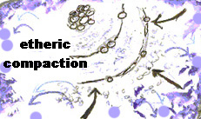

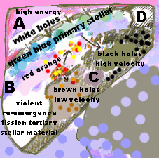
Adjacent cosmic bubbles or universes have ever changing gradients of equality and inequality.

Black holes may slow down their drainage or even manufacture and eject tertiary stellar material or stars because fusionable elements are spending longer together.

The Universe is organic.
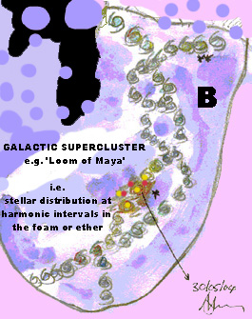
The arithmetic array called the ‘Loom of Maya’ demonstrates that from 13 harmonic intervals a DNA type spiral will emerge.

Matter, Music and DNA have a great deal of structural attributes in common.

In a cosmic foam modelled by wave theory, harmonic chaos forms such as DNA will spontaneously emerge along harmonic principles.

The cosmos is a study in fluid dynamics and wave theory.

Our little cosmos is one bubble in many – perpetually expanding and contracting and exchanging substances with adjacent physical realities.

Quantum Physics and Superstrings are too rigid with Fixed speed of light to model the organic complexity of the interchanges.

e.g. Planck’s constant – distance between atomic shells is not a constant.

e.g. rewarming of the cosmos has taken place contrary to the Big Bang – new free energy entered into the equation causing the organic breathing effect – no big bang or big collapse – just an equilibrium.
