APPENDIX 2.
NUMBERS AND AGREEMENTS ILLUSTRATIONS.
From Chapters 03 and 12-14

COSMOLOGY - PARTICLE PHYSICS - SYSTEMS THEORY

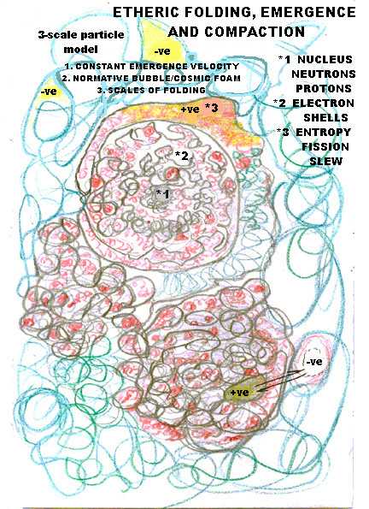

Ever moving sub atomic particles of the ether are being pressed and compacted by the emergence of new material in and around the bubbles in the turbulence. Inside these bubbles or atoms, electron shells are being propagated like standing waves through a medium of finer and finer energy. At the heart of this bubble, protons and neutrons are being continually added to by emergence and lost by entropy.
There are no perfect pristine atoms – they are harmonic strange attractors in the chaos of etheric turbulence.

