APPENDIX 3.
NUMBERS AND AGREEMENTS ILLUSTRATIONS.
From Chapters 03 and 12-14

COSMOLOGY - PARTICLE PHYSICS - SYSTEMS THEORY

The solar system chemically deploys itself like a dualistic periodic table

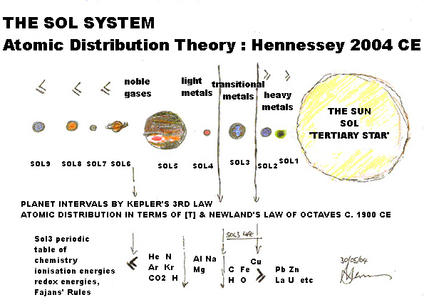
Jupiter a self assembling gas giant would tend to make light metals and semi-conductors/transitional elements around its core as the products of emergence.
More are made around the seed rock at the planets core because that is the centre of matter and of gravity.
As these deposits of aggregate build up they form a porous skin analogous to the conducting layer of a capacitor as used in electrical circuits to build up high voltages.
The suns recent unusual electromagnetic output will drive the electrostatic charges around Jupiter’s core up to massive levels of potential difference between the outer skin and the inner emergence stream at the planet’s core.
When a critical threshold is reached the massive charge will surpass the electrovalent constraints of its boundaries and discharge as a spark into the planets core creating a fusion reaction. [see below].
Comet Shoemaker Levy 12-14 a plutonium comet can further complicate the new novas fusion because its heavy metal salts will facilitate fissionable discharges.

