HX ASSEMBLER

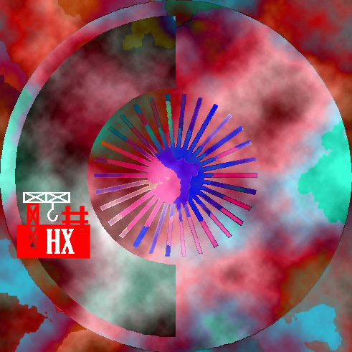

ANDREW HENNESSEY
nanosoftware for hitek

OUTSHORE MULTIMEDIA
'NEVER SEEN ANYTHING LIKE IT !' EDITOR, JOINERS MONTHLY

