[HX] Assembler Software Manual
SECTION 2: GENERAL SYSTEMS THEORY
INTRODUCTION: The Cosmos is in a state of flux.

- A transfer of energy between two points or systems via a common intervening medium is a process called e.g. Osmosis in Biology, Transference in psychology and the electromagnetic [Lewin, Kohler], current in electricity [Ohm], current in Chemistry [Fajans' Rules] . [a Universal state of affairs i.e. some A to some B through some common C with at least the natural intervention of some D]

- The most basic and tautologically true of an infinite number of transfers of energy in the Cosmos of 3 dimensions of space and one of time is between two systems.

- This basic transfer can be modeled in several ways.

a. Osmosis. i.e. The diffusion of a high concentration to an area of lower concentration through a semi-permeable membrane also as Fajan's Rules of atomic Chemistry applied to the migration of electrons.

b. As a metaphysically continuous extension of one system into another, where the second system 'Emerges' out of the potential created by the activity of the first. e.g. Morphogenetic Attractor [Langton C], Evolutionary Vacancy [Goodwin B] - as a Field in Psychology [Lewin K] and electricity [Ohm's Law, incorporating potential difference of energies as Voltage and resistance to the passage of energy from high to low potential.]

c. The relationship between the two systems can be empirically modeled by an inverse square power law i.e. The more one system increases in magnitude, the more the effect of the other system diminishes in turn. This can be more attenuated and imprecise at increasingly larger scales of relativity of mass.

d. A binary and tripartite arithmetic, can be used to model this transaction, where system A, system B and the common medium system C have a holistic relativity which can be represented as integrated or disintegrated in whole or part by 1's or 0's denoting on/off, extant/disabled [Boole G].

e. At any time 1, there can be eight essential states of that Tripartite Relativity. These 'essences' or 'atomic state descriptions' at time 2 can be any of the other eight. The number of possibilities for changes of state is modeled by a closed set of 64.
When the 64 transitions of state are tabulated by placing states of change in graded relativity or chaos or non-structure in sequence with time, we end up with a metaphysical model of the activity of elements in the periodic table of chemistry, where top left, the reactive elements, bottom right the most structured, and in the
middle, transitional states which are complex.
Mathematical modeling of spontaneous emergence for artificial life experiments [Langton 1992] with the same arithmetic criteria as these essences produce the same Periodic Table of states.
From this metaphysics can be derived an Octal Arithmetic with an unusual concept of zero, for zero in this system has substance i.e. There is no absolute zero.

There follows 3 examples [2.1 – 2.3] of the knowledge representation system. This uses small business and their activity classified with this 3 part semantic system and its aspects called; Macro, Meso, Micro.

2.1. Arts - Music and Multi-Media
2.2 Industrial Manufacturing - Light Engineering
2.3 Service - Insurance

MACRO. THE PHYSICAL/ATOMIC COMPONENTS OF THESE BUSINESSES ARE AS FOLLOWS.

e.g. 2.1.- MACRO. fiddle, harp, keyboards, studio recording components, sound mixing facility, strings, CD/Tape duplicator, Minidisk, P.A. System, Transport, music stand, instrument case, tuner, lights, lighting desk, compressor, pre-amp, effects processor, microphones, stands, computer, software, peripherals etc.

e.g. 2.2 – MACRO. lathe, metals, cutter, sweeper, shop floor clothing, gear and boots, tools, bench, drill, workshop, first aid box, lighting, storeroom, drawing/stencil board and printer, oxy-acetylene torch, arc, welding gear, trolleys, coolant, polisher/buffer, chemical solutions etc.

e.g. 2.3 – MACRO. car, clothing, suit, PC, mobile phone, hard copy filing system, stationary, photocopier, Office, computer and network peripherals, petrol, audio-visual presentation kit, overhead projector, whiteboard, laptop and modem, office furniture, briefcase, clients, customers, leaflets, potential customers etc.

MESO. THE PRODUCT & MEDIA OF THESE BUSINESS 'SYTEMS' ARE AS FOLLOWS.

e.g. 2.1 MESO. - albums Celtic, albums rock, albums dance, albums story, multimedia books on CD on mysticism, hard copy tune books, logic audio recording software, concerts, performance and events supplied and tours done by company bands, new midi instruments invented, ambient and meditational video and audio’s, technical papers on new musical theories, interactive CD-ROM and multi-media package on Philosophy for Children, secure website for sale of soundfiles and other product.

e.g. MESO. - 2.2 - oil rig parts, ship parts, motor parts, alloy parts to industrial specifications, hard alloy, soft alloy parts, thermophilic alloy, civil infrastructure components turned by spec to order, trawler maintenance, car and lorry structural repair, ad hoc building and roof components designed and manufactured by consultation.

e.g. 2.3 MESO. - domestic surveys, commercial property surveys, domestic and commercial policies, PEP's, Equity Investment, stock brokerage, actuary and risk assessment, bank and investment portfolios, building society and investment house policies and procedure, capital returns for business and client,
Leaflets and advertising packages - multi-media, TV, radio, cinema, etc

MICRO. QUALITATIVE ASPECTS ADDS/ANGLES/DISTINCTIONS/DESCRIPTIONS

e.g. 2.1 MICRO. - Original music/ various and diverse idioms, original story, cutting edge web site, diverse - one stop catalogue, secure for E-commerce and credit card transactions, high quality international & high tech delivery company used

e.g. 2.2 MICRO. - parts to order, small runs - fast turnaround, good service and maintenance backup, high skill level, One-Off's, diverse projects, great experience

e.g. 2.3 MICRO. - proven track record on investment/stock portfolio, good payout and premium record, speedy and efficient processing of clients needs.

The basic 3 part relationship either have or have not structural identity whenever the underlying function is valid in relation to the context.
i.e. some form of competition may disintegrate the function of the system's 3 new attributes :
i.e. (Sx, Ay, Ez) have structural integrity, and (S,A,E) do not -

The eight essential octal and Boolean states can be generated from synthesis of the 'a priori' diagrams in relation to the integrity or disintegrity of the 3-part transaction.

T, (time/context).

S S S S Sx Sx Sx Sx
A A Ay Ay A A Ay Ay
E Ez E Ez E Ez E Ez

The following narrative relates the behaviour of the 3 part transaction model in terms of the assimilation of a process or sub-system by a system using osmosis.
The algebraic model uses syntax to present some simple exchanges within a biological system.
In the next section [HX] will give this three part systems behaviour of; object, process and quality, or; noun, verb and adjective, or neutron, proton and electron etc more detail.

A TRANSACTION MODEL IN BIOLOGY

1. The niche that provides the context to contain this organism/organisation/system is represented by various factors or groups of letters.
Those factors directly used by the organism are ASB(E) or food and energy input to the Energy Gathering Mechanism VN.

2. The Meso - processing E (Evolutionary Advantage) for use at Q. ASB takes E - Evolutionary Advantage forward.

3. Paying a toll of (B) at a membrane (P) for the furtherance of AS(E).

4. The toll (B), paid, mechanism P - the site of the toll brings and enables a carrier mechanism RV(T) to bind AS(E) and convey it down pathways that demand it.

5. Part (T) of RV(T) can only take AS(E) forward if it can locate its binary receptor mechanism RV(Y).
T and Y are mutually attracted, however Y is a resource which is only produced when the organism as a whole is competing well with 'exogeny' i.e. the contect at factor Q - where Q is a chaotic energy demand that affects the integrity of organism Z.

6. Thus when Z is doing well, Y enables the progress of AS(E).
Y represents the potential ergonomic exhaustion has to debilitate the organism to a state of extinction, making the quality of substance of Z, reserves etc. an important factor in surviving the competitive stress of Q.
Q on the other hand represents the freedom of external factors to interfere with the evolution of a system.
With Y present, AS(E) is taken to and bonded to mechanism W which further filters out RV.

7. The number of exchanges from one mechanism to another represent, here, the increasing complexity which binds and processes, refines and directs food/energy input into the specialised compartment of the Micro which is interphasing with the environmental competition.

8. 'Food' factor (AS) is then expended to convey (E)
Evolutionary Advantage to the Micro or Assets of the organism - enabling Z to hold its own, And where Z has advantage over Q, it produces Y - its potential for continued survival.

This process of natural selection in terms of increased stress on the umbrella of systemic integrity may be illustrated at work within the algebraic model in the story of the dinosaur .. where supported by the body of energies that comprised the atmosphere and its trophic range - under this umbrella it flourished, finding a tolerable equilibrium between air temperature, body temperature and energy consumption, until sudden massive scale change took place.

In the next section, the [HX] Language will give more detail and substance to natural processes and transaction modeling in complex systems.

APPENDIX
HERE ARE TWO EXAMPLES OF THE BOOLEAN LOGIC.
FIRSTLY THE LANGUAGE [A] WITH 729 TIME2 STATES, THEN THE LANGUAGE [T] WITH 64 TIME2 STATES.

THE LANGUAGE [A] SAMPLE



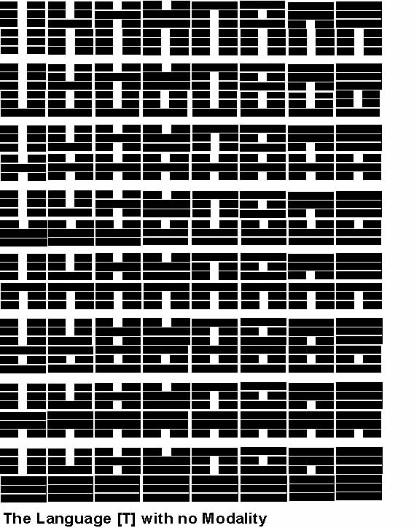
THE LANGUAGE [T]

There follows eight process descriptions for the eight tripartite atoms of the language [T].

1. MACRO = 0, MESO = 0, MICRO = 0.
In the system, all is in flux and there is no relativity or congruence between the context, the object and its activities.
There is currently no contextual environment for the development, redevelopment or continuation of any system and the qualitative aspects of evolution within this dissonance have no emergent aspect that can be measured at this time according to current empirical process.

2. MACRO = 0, MESO = 0, MICRO = 1.
The limited integrity of the past has had the qualitative capacity to emerge an asset, the Micro, but at this time now, (presently at timeX), the system has no systemic integrity. The emerged asset, though, having persisted from a previous time interlude is currently of high quality and integrity.

3. MACRO = 0, MESO = 1, MICRO = 0.
The lack of supply of systemic precursors caused by the discontinuity within the context has had no detrimental effect at this time, timeX, on the integrity of the persistent systemic mechanics. The facilitation of systemic growth, though, by the Meso, has ceased because of this lapse in the supply of precursors to the systemic mechanism and therefore no new assets and tools have been produced for the evolution of the system.

4. MACRO = 0, MESO =1, MICRO = 1.
The lack of systemic equilibrium and integrity due to the collapse of the precursor supply to the equilibrium from the aggregates of the context has not interrupted the integrity or persistence of the mechanical attributes within the system at timeX as it continues to emerge asset.

5. MACRO = 1, MESO = 0, MICRO = 0.
At timeX, the present, an integrated supply of systemic precursors has emerged as an event, the Macro, but has no telic properties at timeX such that any new mechanical attributes have organised or have had such time that would have produced a qualitative asset as per conditions of observation.

6. MACRO = 1, MESO = 0, MICRO = 1.
At timeX, the present, an integrated supply of systemic precursors [Macro], have emerged a qualitative event [Micro] - though the mechanics that supplied it were transparent to observation.

7. MACRO = 1, MESO = 1, MICRO = 0.
At timeX, the present, the contextual supply of systemic precursors to the emergent mechanics of the Meso and its self-regulating equilibrium is of insufficient gradient, velocity and content to produce a measurable qualitative asset of any integrity under the assumed contextual conditions.

8. MACRO = 1, MESO = 1, MICRO = 1.
At timeX, the present, a fully emergent, self-regulating system, producing assets of measurable qualities through viable mechanical integrity is observed to conform to the criteria of judgements imposed by the observations and criteria of systemic success.

The eight descriptors, the eight tripartite atoms of the language [T] at time1, describe an event deltaT at time2, producing a set of 64 logically real essential numbers that are unique state descriptions fully describing every change of systemic integrity at time1 and time2.

The one rule of assumption that drives this set of rules of derivation is that in all (universal) cases, a larger system of aggregates, universally and autonomically contributes to a smaller system through a common medium with also the intercession of at least a common other.

©2004 OUTSHORE MULTIMEDIA ANDREW X HENNESSEY HND.BIOL KT.

