PARANORMAL FLASH

‘There are more things in heaven and earth, Horatio, Than are dreamt of in your philosophy.’
Hamlet, Act 1 scene 5, William Shakespeare

From that innocent sounding quote it can be taken that the world being full of perfectly reasonable men and women just needs some simple, easy to understand physical evidence and proof to create a new kind of science and philosophy of life that embraces the most profound idea of the soul and eternity.
The world of science though, tending to be mortal and existentialist, struggles with the nothingness of being, and the soulless emptiness of biochemical experiences.
Karl Jaspers was one of those existentialists who sounded really positive about leaping into new ideological territory.

From Wikipedia: ‘In Philosophy (3 vols, 1932), Karl Jaspers gave his view of the history of philosophy and introduced his major themes. Beginning with modern science and empiricism, Jaspers points out that as we question reality, we confront borders that an empirical (or scientific) method can simply not transcend. At this point, the individual faces a choice: sink into despair and resignation, or take a leap of faith toward what Jaspers calls Transcendence. In making this leap, individuals confront their own limitless freedom, which Jaspers calls Existenz, and can finally experience authentic existence.

Well there is actually a third way because today’s digital camera and flash can act like the eyesight of a traditional Seer or Hedge Witch and pick out the amazing fact that there are all sorts of life forms floating through the air.
These go about their business usually unseen by human eyes and appear to be part of a big sea of energy. Indeed many of the creatures to be photographed tend to look like they are marine in nature.
If the human brain one day starts to see this kind of thing, then it becomes only natural that the subject is going to get a little disturbed as there is absolutely no precedent for this material in public domain literature.
Unless one goes to the Theosophical or indeed Masonic libraries and start perusing books by 19th Century authors; E Swedenborg and e.g. C W Leadbeater in his ‘The Hidden Side of Things’.

If the constant parade of strange stuff starts to bemuse the victim, then there is little recourse but to seek medical help.
Unfortunately the doctors of western medicine tend to be rather unsympathetic to the notion of otherworldliness.

From ‘Wikipedia’: ‘Jaspers set about writing his views on mental illness in a book which he published as General Psychopathology. The two volumes which make up this work have become a classic in the psychiatric literature and many modern diagnostic criteria stem from ideas contained within them. Of particular importance, Jaspers believed that psychiatrists should diagnose symptoms (particularly of psychosis) by their form rather than by their content. For example, in diagnosing an hallucination, the fact that a person experiences visual phenomena when no sensory stimuli account for it (form) assumes more importance than what the patient sees (content).’

With half a gallon of medication ingested therefore, merely being plagued by things that people flatly deny the existence of, descends to a lesser priority as the body serves up notification of impending organ failure from pharmaceutical overload.

Having heard that strange beasties can be safely photographed and recorded without the aid of mind-altering drugs so favoured by native tribes, and without any need to go into some jungle or desert or ice cap, the paranormal researcher heads outside at night … being careful not to attract the attention of the local youths .. and starts flashing away in hope that strange otherworldly beasties are going to show up instead.

It is possible to film one creature portrait in every twenty taken.
With some careful contrast adjustments in postproduction and sometimes without any at all, a variety of forms both indoors and out that are obviously not accidents of light or camera use can be shown.

Finally, empirical evidence of a world beyond Biology and materialism and Psychiatry.

The Psychiatrist argues however, (usually to a captive audience), that All experience is a Biochemical experience. i.e. All strange beasties that float about in the air are therefore the results of biochemical dysfunction in the Human.
Worse still, the auxiliary forces of Psychiatry and materialism at large in the world, namely those alleging to be skeptics, will argue that all photographic evidence usually has a rational explanation in terms of; the mechanics of the camera or misuse or inappropriateness of the lens and lighting, or environmental conditions.
Proof of ‘beasties in the sky’ is always to the professional skeptic therefore a ‘camera artifact’, and if it isn’t or looks clearly like it really is something important, they further retreat to either name calling, or the use of the philosophical position of Descartes – i.e. ‘How can we know anything’ as its all in the mind anyway. [Epistemological skepticism].

If one were hoping to impress anyone with rational proof of life beyond biology – one would in truth be on a hiding to nothing or in line for a rather big depot injection.

According to inductivism, scientific research (indeed Psychiatry) proceeds from observations to theories. Psychiatrists begin with experiments, finding out what happens in specific cases. They then use the results of these experiments to develop general theories about what happens in all cases.

The classical example from David Hume goes from a series of observations:
Swan no. 1 was white, Swan no. 2 was white… Swan no. k was white… to the general statement: All swans are white.

Thus for Psychiatrists; paranormal sky beast 1 was hallucination, paranormal sky beast 2 was hallucination .. paranormal sky beast k was hallucination .. They then progress to the general statement: All paranormal sky beasts are hallucinations. i.e. All paranormal sky beasts are the product of human brain biochemical dysfunction.
All we really need to do to produce a change in the idea that every paranormal sky beast in the universe is created by biochemical dysfunction in the human brain is to derive ONE contradiction – and not in fact hundreds or thousands.
If we can produce merely one piece of evidence to suggest that some paranormal sky beasts are not biological brain dysfunction or are not the provenance of a malfunctioning camera chip then at that point we have totally changed the World.
For, being perfectly reasonable scientists, we then must, rationally, and logically, move from the position that All paranormal sky beasts are dysfunctions of human brain biochemistry to the position that merely Some are dysfunctions of human brain biochemistry, but also, that some are Not; some paranormal sky beasts are in fact some new scientifically valid phenomenon, some observably of organic provenance. Some paranormal sky beasts exist in the empirical world beyond the fabrications that can take place within the mind and brain biochemistry of the beholder.
Some paranormal sky beasts, according to the empirical evidence that I present, are real sky beasts. I have just therefore falsified the philosophy of the material world with my photographic evidence and have demonstrated that beyond the grave is perhaps an endless cycle of non-corporeal energy-based life forms that appear to have survived physical death.
I falsified existentialism and its biological basis with a basic digital camera and flash that anyone can buy and use out of Wal-Mart for a few dollars, and for a few dollars more, one can use Photoshop Elements to enhance the contrast and lighting in the night-time pictures.
From ‘Wikipedia’. ‘Falsificationism is a rival account of the processes involved in scientific and Psychiatric research to inductivism. Inductivism holds that science proceeds from observation to theory, beginning with observations derived from experiments, and extrapolating from these to general laws. Falsificationism suggests that science proceeds in the opposite direction, beginning with scientific theories or “conjectures”, and then conducting experiments and eliminating those theories that are falsified by results.’
This in fact sounds perfectly reasonable. Our western clinical warders, therefore, are merely awaiting an opportunity to see new rational evidence to allow them to change their highly paid minds.
Karl Popper established guidelines for such Scientific method and practice in 1962 in his book, ‘Conjectures and Refutations.’
From ‘Wikipedia’, ‘Falsificationism exploits an important logical point: falsifying instances are more significant than confirming instances. If we have a general law, and conduct an experiment that confirms it, then we still do not know whether the law is true. It remains a live option, but nothing more. If, on the other hand, our experiment contradicts the theory, then we have discovered that the theory is false. Unexpected experimental results are far more significant than expected results.
Whether or not a theory is in principle falsifiable, i.e. whether or not it makes predictions that can be shown to be either correct or incorrect, has been proposed as a criterion for distinguishing between science and pseudo-science.’

Good news for the guy with the camera that’s been having a hard time therefore, for allegedly all he needs to do to get some legitimacy and sanity attributed to his life experiences is simply show some decent empirical evidence to his local Psychiatric Overlord.

Bad Move.

In any event the tide of popular digital camera filming from places such as Mexico City, mainland USA, South America, United Kingdom, Scotland, Russia etc has amassed a mountain of good clear footage of UFO’s flying on propulsion systems beyond the dreams of Einstein and what today passes for Science.
Cleary half a million silicon camcorder chips are not hallucinating.

Indeed human beings can be seen floating through the air as if they were strange sky beasts themselves by means of the practice of alien inter-dimensional physics.
Harvard Professor of Psychiatry John E Mack, now deceased, didn’t last too long in his quest to legitimize the experience of humans.

The cover up though continues, and the mental health industry has never been busier with people complaining of aliens and sky beasts and other such things. It remains therefore a restatement of the official Government position to quote a UK Black Ops guy quoting ex-Prime Minister Margaret Thatcher when she was presented with evidence of alien intrusion. ‘‘You can’t tell the people’ Mate !’
That’s because the only other legitimate option is to medicate them for the outrage on discovering their betrayal would be too great.

It may well be that there is enough of the extra terrestrial pie to go around, but there are plenty people who never survived in the queue to get their piece of the action. These vulnerable people were disenfranchised and disintegrated by the squalor of soul-less materialism and its operators.
The following photographs illustrate the ‘sky beasts’ that could technically change the world of materialism forever.
There are also some other photographs relevant to other stories presented here.

Orb or Spirit progressively materializing

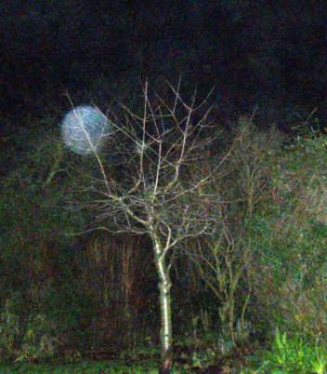

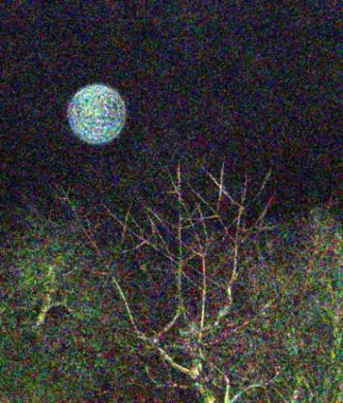

note the non-arbitrary structural scarring on this being.

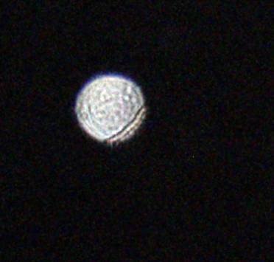

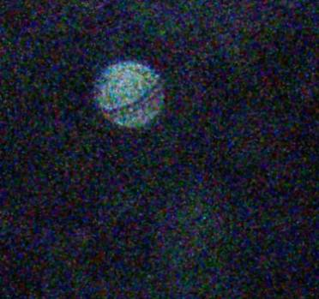

Orb/Spirit dimensions approximately 4 feet in diameter.
The creature is showing signs of ‘super-natural’ recycling and damage.

Anthropomorphic ectoplasm of a demonic nature.

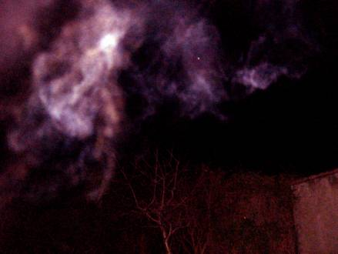

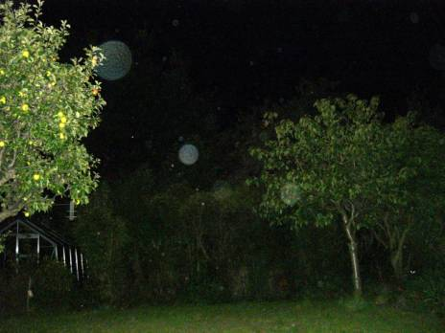

Small orbs taking off in wedge formation like pigeons amongst bigger beings – one given perspective as a ‘natural’ object when partly obscured by the left field tree.
The V-formation of the little orbs is reminiscent of a little flock of birds, suggestive of natural patterns and relationships in life that persist beyond the physical forms that we see with our eyes.

Abduction prelude 1981 plus strange being 1996, 2003.

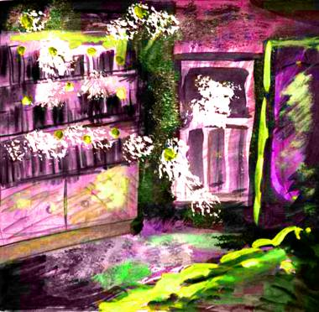

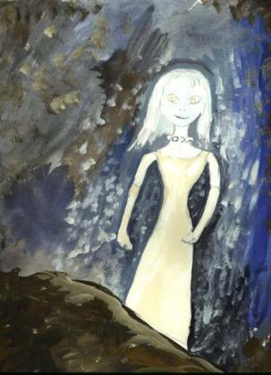

Who would believe that ?

The flying triangles mentioned in Interstellar Contract Hit.

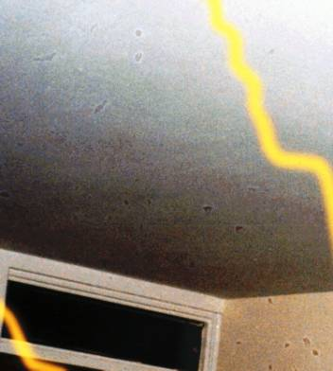

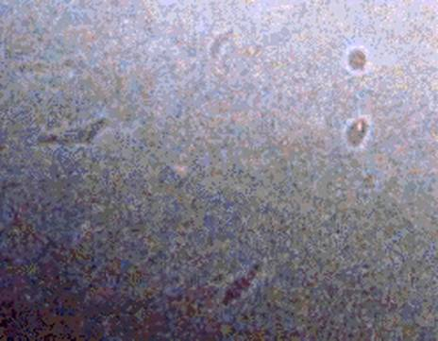
Scottish seafood is usually served with chipped potatoes, in fact I could have invited this strange vampire lady and her triangular pets for ‘nosh fer a too’.
[Scottish vernacular for ‘dinner for two’ is also a traditional name for a Vampire – Nosferatu !!!]
Orb showing chaotic fingerprint of energy.

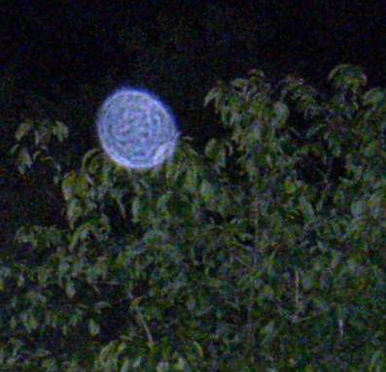

A different structure of energy being. (Turquoise globe)

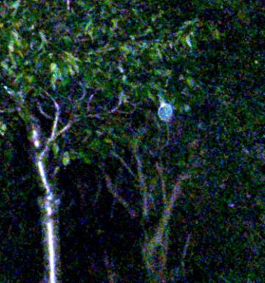

A larger Orb or energy being approximately 10 feet across
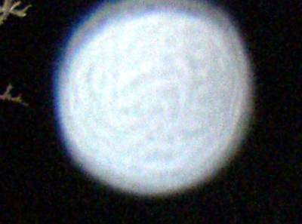

Crichton Castle – a UFO and Underground window area


Directly on top of an adjacent cavern system, scene of haunted parades of the faeries, blue ladies, and has a very strange watchdog – a werewolf. A local valley is called by the locals ‘dinosaur valley’ because of all the big chewed bones lying about. Crichton Castle is also a UFO landing area and drop-off zone for interstellar visitors.
Bronze Age Reptilian stone head in Rosslyn Glen near the famous Blueblood chapel. Carved on an ancient ‘spirit rock’.
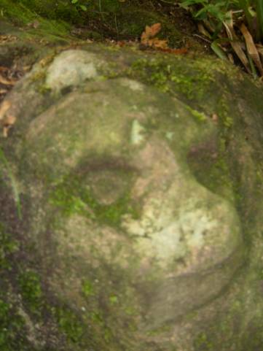

13th Century carving of a Grey in St Giles Cathedral, Edinburgh called the ‘Corble Stone’.
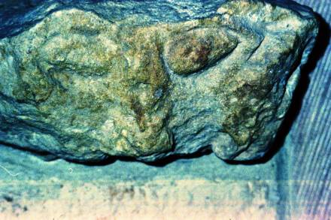
Alien technology the size of a flying toaster hovering in my back garden.

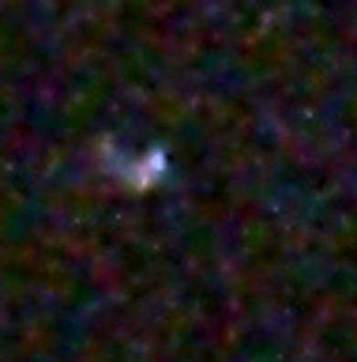

Lothian Regional Transport in Edinburgh, telling it like it is.

