Sacred Wheel Teachings and Self-Development Techniques
by Swiftdeer
1986 Copyright. Deer Tribe Metis-Medicine Society
HOW TO TOUCH LIFE AND OTHERS WITH YOUR BEAUTY
WHEELS AND KEYS FOR HEALING OTHERS
INTRODUCTION 2
PROLOGUE 3
The Twelve Magical Worlds 3
The Twelve Magickal Worlds Wheel of Constellations & Planets 5
Basic Teaching Wheels 6
The Elemental Powers 6
The Four Worlds 7
The Worlds of Grandmother Earth. The Basic Alchemy Wheels 8
The Mineral World (the Holders of Energy) 10
The Plant World (Givers of Energy) 11
The Animal World (Receivers of Energy) 12
The Human World (Determiners of Energy) 13
Balanced Choreography of Energy 13
Powers of the Four Directions 14
The Chulaqui-Ouodoushka 'Orende' Movement Wheel 15
The Star maiden's Circle 16
The Sacred Teachings of the Seven Arrows 19
The Twenty Count 20
THE SACRED MEDICINE WHEEL 25
The Seven Virtues of a Warrior 27
FOUR ENEMIES OF HUMAN'S WHEEL 29
WARRIORS PATH TO THE "FIRE FROM WITHIN" 30
The Human Flowering Tree of Life 32
The Human Assemblage Point 33
The Human Shields 35
Seven Dimensions of "Reality" Wheel 43
Orende Levels 43
The Naturals 45
Sacred Platform 50
The Human Wheel of "Love" Relationships-Choices 53
Tyrants Masks Wheel of Power 54
DANCING IN THE DREAM MEDITATION 56
HOW TO TOUCH LIFE AND OTHERS WITH YOUR BEAUTY.
WHEELS AND KEYS FOR HEALING OTHERS 57
PRACTICAL USE OF HEALING CRYSTALS 58
STEPPING INTO THE SILENCE 62
This way is an all-consuming, all-illuminating lifelong commitment that will tolerate NO illusions. It is not a hobby, sport, recreation, diversion or a fad.
As this Warrior Task Assignment journey begins, we must approach it as we would a pilgrimage to a Holy Shrine. We must hold in our Hearts, the knowledge that there is only one true way or route to this shrine COMMITMENT and DISCIPLINE! We take to the road with certainty and a strong will and intent to reach the goal. As we proceed, however, other roads that seem to be more attractive, more enjoyable, more socially acceptable, or more physically (economically) rewarding—or merely easier or shorter— will always appear. In our confusion it may soon appear as though the other roads better match the superficial appearance of what we think the path "ought" to look like. Instead of following the "true" route to the "shrine; we then find ourselves wandering in all directions with our energy scattered, racing after what entertains us at the moment and losing the possibility of reaching the shrine!
By embracing the Warrior's Path we will find our way home! We will discover our Inner Heart!
Swiftdeer
INTRODUCTION
The Deer Tribe Metis-Medicine Society, through the auspices of the Shamanic Lodge of Ceremonial Medicine; has chosen a select set of Sacred Wheel Teachings and Self-Development Techniques from the vast amount of knowledge found in the Inter-Tribal, Native-American Traditions. Specifically, the information and knowledge contained in this Training Manual and the further teachings found in our Apprentice Teaching Manuals comes from a "Body" of Sacred Knowledge of Traditional Native American Elders called "TWISTED HAIRS". These Twisted Hairs were all "WARRIORS" and came from many different tribes from all of North, South & Central America which was called Turtle Island. A Twisted Hair Warrior was also, usually, a Elder and respected Medicine Man/Woman, Shaman, Sorcerer, Magician or Wizard and was a member of these particular tribes "secret" Medicine Society or Magickal Lodge. Therefore, they were considered to be a Man/Woman of Power and Knowledge. What seperated a Twisted Hair from a Traditional Medicine Person was their "ability" and "desire" to seek knowledge from all sources! For what ever reason, these men/women were not content to blindly accept the limitations and bounderies of their tribe's traditional teachings; and chose, instead, to travel and seek knowledge from every direction of the Wheel of Life in order to get to their Center and come into perfect alignment with the Great Spirit.
In our people's language, the hair symbolized knowledge and, therefore, a "Twisted Hair" was one who wove knowledge from all sources into their Path with Heart and made it their knowledge. They learned to utilize every available resource around them in accordance to the Great Law: "EVERYTHING IS BORN OF WOMAN" & followed the two other Great Laws of "MAXIMUM EFFICIENCY WITH MINIMUM EFFORT", and "NOTHING MUST OR SHOULD BE DONE WHICH WILL HURT THE CHILDREN"! In this way, they became "Rainbow Warriors" and began to meet with each other,sit in council and exchange openly their various sources of knowledge. At a very historical meeting in 1224 in OAXACA, Mexico; they met and banded together into a very secret Medicine Society/Magickal Lodge and named themselves the Twisted Hairs Medicine Society of the Sweet Medicine Sun Dance. Their "Council of Elders" came to a unanimous agreement for membership and established a Circle of Law to help facilitate the sharing of their combined knowledge with anyone whose primary reason for choosing a physical body was for the purpose of seeking Pleasure and Knowledge in order to eventually become Enlightened and to learn to become a "Human Being" who touched themselves, life and others with Beauty!
As a part of this process of becoming an Enlightened Human Being, these Elders set up a series of Ceremonial Gateways and Warrior Task Assignments to teach the "seeker of knowledge" to become self-reliant and self-actualizing. They learned to flow with the constant energy of the Everything in a Harmonic Way by virtue of learning to confront the many Tyrants life's changes presented to them with a sense of pleasure and beauty. They learned to stay "centered" even in the midst of total chaos and how to follow the Great Sacred Laws and avoid arbitrary civil, social and religious laws. In essence, they learned to Walk their Talk and Touch the World with Beauty as they sought Knowledge In The Great Vision Quest called LIFE. It is our hope that the material contained in this manual will allow you to make the decision to become a Warrior, to teach you how to flow with the affects of Nature, & learn how to never be at the "Effect" of anyone, anything, anywhere at any time in any way. In conclusion, we trust you will use this material to Take Your Power and become & remain the Cause of Your Own Circle of Life.
PROLOGUE
Historically, part of following the Warrior's Path Involves setting out on the "Warrior's Errantry" Vision Quest. This usually takes place within the Fourth Gateway of most spiritual paths and lasts through Initiation into the Sixth Gateway via the Warrior Task Assignments within each of the five aspects of the human. This also necessitates proper alignment with the four elements and the four Sacred Worlds.
Basically, this process Involves taking the warrior far from the comfortable, familiar environment they are used to, and exposing them to experiences that demand resourcefulness and ingenuity in order to find and establish the proper weapons/tools of survival.
Ironically enough, submitting oneself intentionally to the potential of frustration and stress—is the essence of growth in the Warriors Way of Enlightenment!
Because the wandering warrior must face new, strange and sometimes startling differences in daily living, all comfortable habits and ruts must be given up for more appropriate behavior to meet the new circumstances. The Warrior Task Assignments force the apprentice to look at new ways of approaching life and provides new weapons and tasks for attaining success!
It is the shedding of all our barriers and reservations and diving Into the total potential of POWER that is the Warriors goal during this quest. A time for letting go of constricting beliefs to gain FREEDOM!
The Warriors Way is exactly what the name implies; a way of directing the days of our life to better produce the likelihood of encountering those experiences that will lead to the enlightenment sought!
4, 5 missing
The Twelve Magical Worlds
"Have you ever noticed how close the stars appear to be at times?' Rainbow asked, hugging Dancing Tree.
"Yes, I have," he said, turning to look at her.
"My grandmother used to say that we see them because we wish them," she smiled. "They become even more beautiful when you think about the teaching of the twelve magical worlds."
"The twelve magical worlds?" he asked.
"It is a Sun Dance teaching." She laughed a beautiful laugh and lay her head back upon her soft pillow of white ermine.
"Isn't everything?" He laughed with her. "Please tell me."
"Well," she began, "the Medicine Woman said there was a dance of prophecy that began a very long time ago. It began out among the stars, she told us. It was a song that belonged to the great Universe. The song grew within its fullness, until finally everything began to sing with it. It was a pure song of the harmony of all that exists, and it painted Its brilliance across all time.
"The beings upon the twelve worlds blinked at the light and wondered concerning the song. And so each of them made medicine. And the medicine flew from one world to the next until it was reflected everywhere. The beings upon the twelve worlds had seen the sign of the thunderbird. And the thunderbird held up an Image to each of the worlds, until all twelve could see the next. They were very surprised to learn that they were not alone within the Universe.
"But more important than this, my little children, all the beings upon each of the twelve worlds now knew that they were not complete. 'We are only partial beings," they cried, and their sadness moved out into the Universe until it was heard.
"It Is so," the Universe answered their cries. "You have awakened."
"The Great Spirit of all the Universe walked upon each of their worlds and veryone became refreshed. Now they felt the joy of birth.
"Where should we go to meet ourselves so that we can become whole?," the beings from all twelve worlds asked.
"Walk upon my robe," the Mother Earth answered. "Walk here, my children, and you can know of each other." "The Mother is made up of all things," the Universe sang. "She is part of all twelve. She is part of all the beings upon all the twelve worlds."
"And the Mother made medicine. The medicine was love and the Universe knew that ft was the song of the light."
"Come," the Mother sang. "Come and be born. You will leave your memories behind. Come and be children together. Come and be sisters and brothers, mothers, fathers, and relatives. I will provide everything. Come and dance together."
"And the beings, many of them, wanted to dance. They wanted to become. And so they were born."
"Little by little, more and more of the beings wanted to become. And the Mother sang her wonderous song. Each of them was given a body-lodge made from the Mother Earth. And the spirit of these things grew among the people of the Earth."
"Each being from each of the twelve worlds brought a special gift with them. This gift was their way of perceiving. It was their spirit. And each of these beings had a special power."
The Mother sang to them of these things saying, "You will become complete people when you have danced with the powers that each of you have brought, Learn together. Teach each other. Care for one another and you will learn of your love for each other."
"What are those powers you spoke of?" Dancing Tree broke in to ask.
Rainbow laughed. "Do you not remember your teaching concerning the medicine wheel?"
"You mean the reflections?" he ventured.
"Of course!" she smiled. " Are you not different from Crazy Dog or Little Wolf?"
"Yes," he frowned, "but we are the same too."
Rainbow sat up.
"There are special things given to all of us, but all of us can learn about our gifts within the Sun Dance."
(Excerpt from Song of Heyoehkah. Hyemeyohsts Storm, 1981.)
Thus we come into relationships to mirror and reflect for one another. We are tools for each other's growth and the more we can truly know this, the faster the movement. There is no need for judgment of a particular relationship as right or wrong. Each relationship is merely the mirroring we need at a particular time for our highest good.
The Twelve Magickal Worlds Wheel of Constellations & Planets

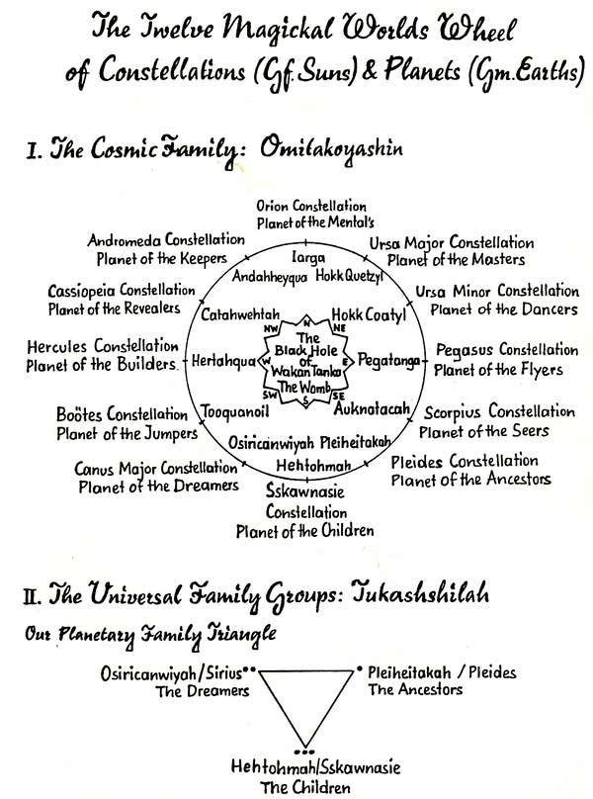
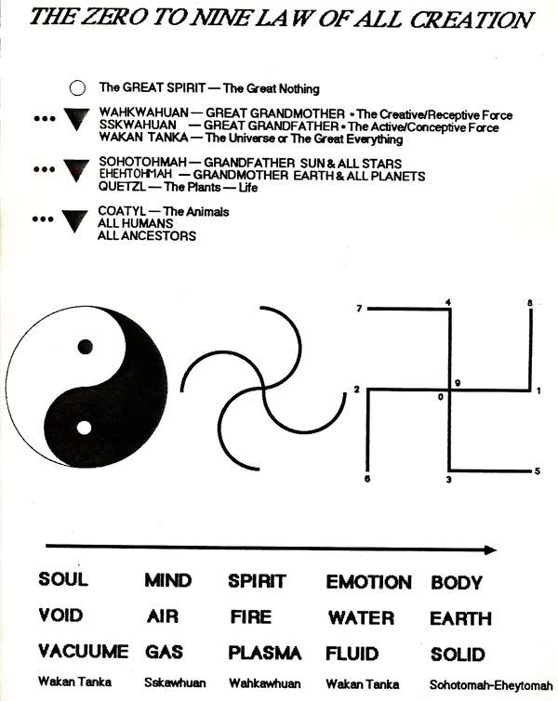
Basic Teaching Wheels
In the Native American world, wheels or circles have been used since the ancient times as tools for teaching the ways of the Universe. Nothing is seen as linear for the idea of a linear existence is considered to be an illusion. There Is no "beginning" or "end". There Is simply a change of reference points. Birth Into physical existence is not the beginning of life (for spirit is eternally alive) but it is a different perception point through which spirit experiences its aliveness. It is simply movement on the Wheel of Life.
Learning of the Universe through wheels offers a more accurate way to perceive how life is completely interconnected with all other life. Flowing, changing and reaching out to touch all forms of all things with Beauty.
All the wheels of the Sundance Medicine Path spin and interconnect with one another in this way.
Not only that, but each position on the wheels corresponds to a particular direction, I.e. the cardinal directions: south, north, west, east, and the four non-cardinal directions: southeast, southwest, northwest and northeast. Furthermore, there are specific qualities and characteristics that exist for each direction. Thus, no matter which wheel is being used, the subject matter is placed in a particular direction because it too has these properties.
The Elemental Powers
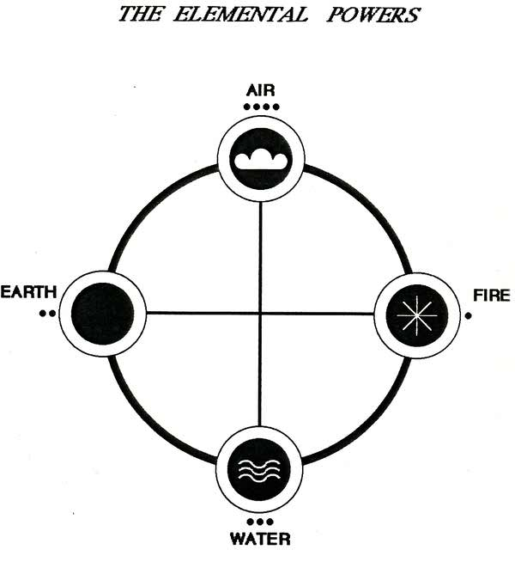

The Four Worlds
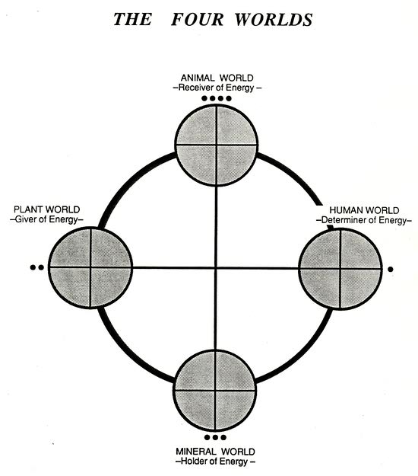

The Worlds of Grandmother Earth. The Basic Alchemy Wheels
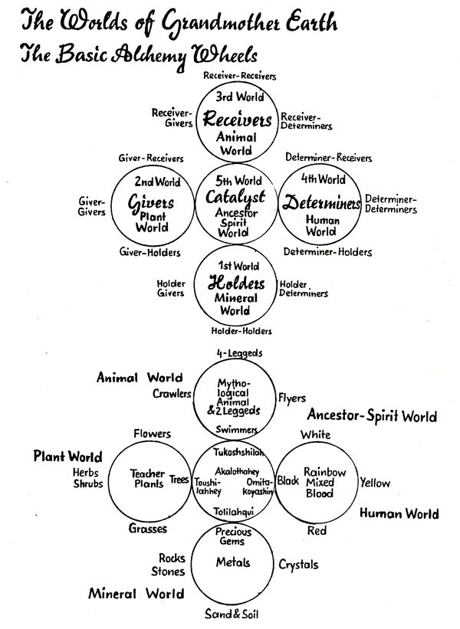

The Mineral World (the Holders of Energy)
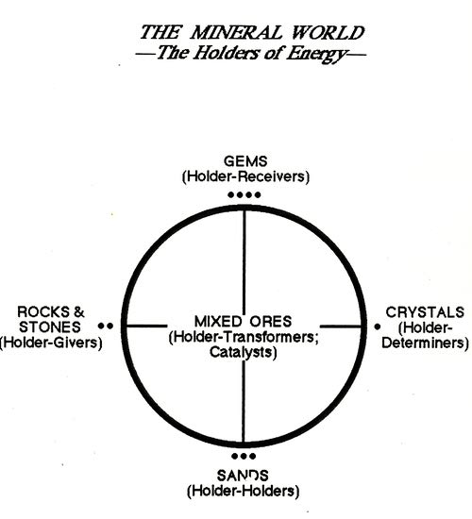

The Plant World (Givers of Energy)
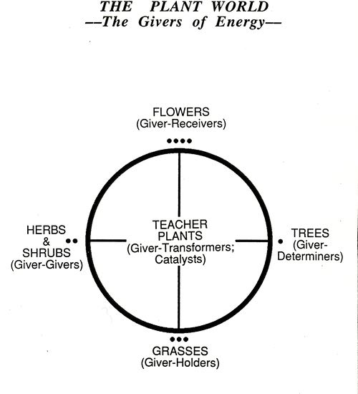

The Animal World (Receivers of Energy)
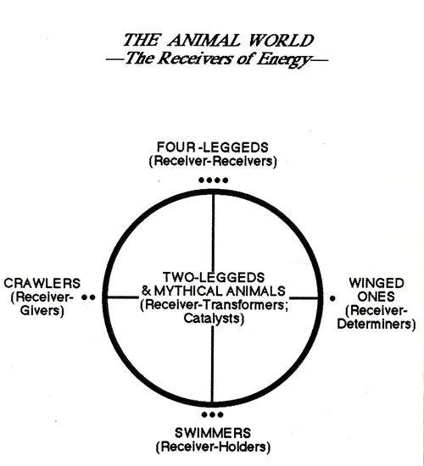

The Human World (Determiners of Energy)
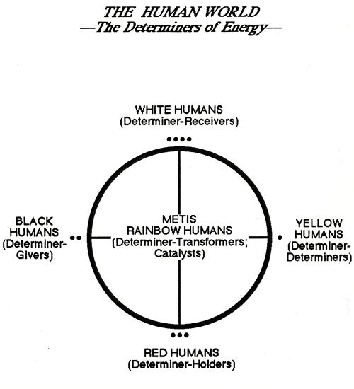
Balanced Choreography of Energy
This wheel describes the most balanced way to use our energy. That is:
to give with the emotions
hold with the physical body (transform via stabilization)
receive with the mind
determine with the spirit
catalyze with the sexual force
Often, imbalance, fatigue and pain are created when these are interchanged. For example, common interchanges are:
hold with the emotions
give with the physical body
determine with the mind
receive with the spirit
Problems often arise as a result of this type of energy choreography because it is not balanced or in harmony with what the emotions, body, mind and spirit were designed to do best.
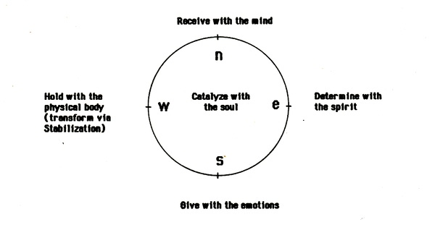
Powers of the Four Directions
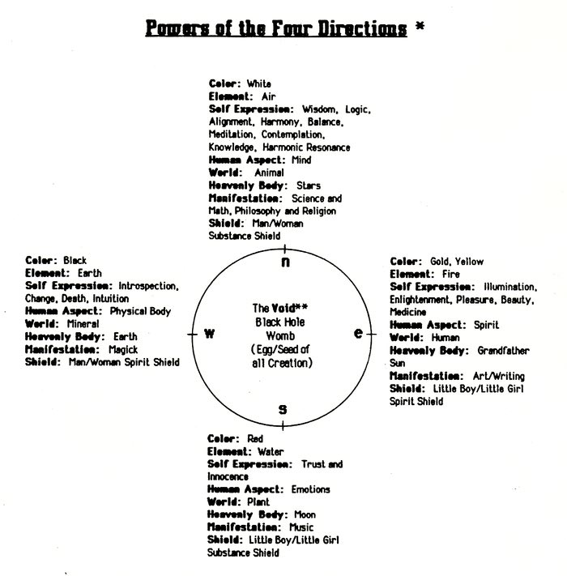
* In the Native American world, the "Power" of anything is its essence and how it gives away and touches others with beauty.
** The center of any wheel is always the catalyst for all other aspects of the wheel.

The Chulaqui-Ouodoushka 'Orende' Movement Wheel
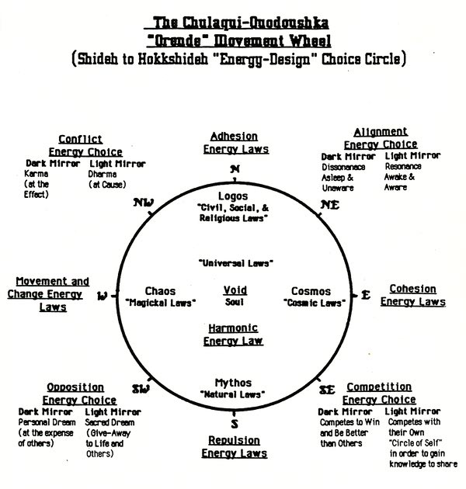
21 missing
The Star maiden's Circle
The Star Maiden's Circle Is the center or Key Driver Wheel for all of the Sweet Medicine Sundance teachings. It describes the qualities and powers of the eight directions and, just as with the Four Direction Wheel, the characteristics of each position are carried over to all other teaching wheels. Furthermore, the Star Maiden's Circle provides a key to understand the choreography of our energy in the Life Dance. It is a very powerful tool for gaining Insight into our psyche - our actions, reactions, desires, beliefs, goals, etc.
Each position on the circle has both a dark mirror and a light mirror. For example, in the south - the place of mythology and entertainment - the dark mirror is mythologies or core beliefs about life which keep us closed down, in pain and at the effect of circumstances rather than free and in power. The light mirror, on the other hand, Is mythologies which inspire us to move through life in balance and power.
As we heal and balance the dark mirrors by opening the symbols and shift all of our mythologies, symbols, daydreams, rules and laws, philosophies, designs of energy, fantasies and concepts of self into the light mirror, then we move from being at the effect and stuck in the Shideh (lower self) to coming into the full power of our Hokkshideh (higher self). Thus, in many ways, the Star Maiden's Circle is a bridge to the Higher Self.
The "Drama" of pain is Blaming others. The "Drama" of Pleasure is accepting responsibility for your own circle of self I
The INFINITY MOVEMENT shows us how we, as humans, choreograph our experience through this Life Dance. It is the double circle, the two opposite energy movements, the masculine and feminine, Wah-Kawhuan and SS-Kawhuan, coming together in unity of feeding and being fed, giving and receiving for balance and the creation of the Beauty Way.
The Infinity Movement shows us how we come to experience the universe in our unique way, how we process our experiences and how we can move out of stuck places in our perceptions into that state of divine understanding known by our higher-self, our Hokkshideh.
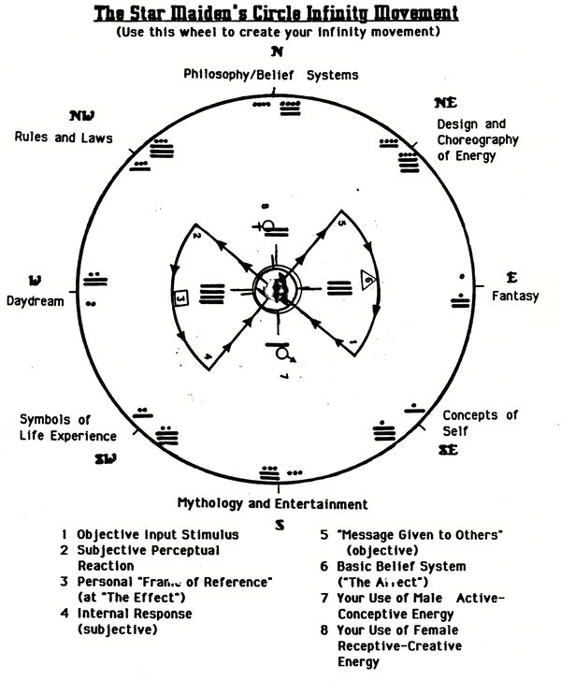
To use the Infinity Movement:
1. Locate your shideh's sitting place from Sunbear's Astrology Wheel and place the (3) position of the Rotating Wheel (on the preceding page) in this direction. Your Infinity Movement is now created.
2. Further understanding can now be obtained by reading the descriptions for each position.
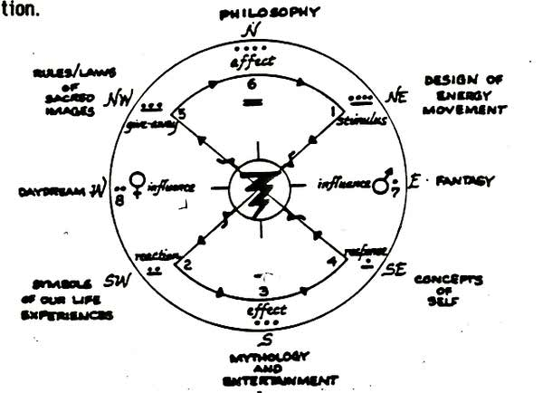
1) This is the initial starting place of objective input stimulus. The place from where you first choose to perceive life. Your SAP's "Place of Selective Perception.
2) This Is your Inner subjective reaction to the Initial input stimulus. How you choose to inwardly react to the outward stimulus presented.
3) Your Shideh's "sitting place" based on Earth Astrology. Your frame of reference from where you choose to perceive life. Your place of subjective-Introspection.
4) Your choice of response to the original stimulus of step 1. The way you want to be seen. Your objective expression.
5) The message you are giving to the world Your Give-Away. The way you are perceived by others. Your "mask of self".
6) The affect of your Give-Away. TV. outward mes^ge you have given to the world. Your concepts of self. Your Philosophy of Life. "The Meaning of Existence."
7) Our influence and use of the Male Active-Conceptive Energy. The seed, image-light-spirit. Psychic-Kinetic Energy.
8) Our influence and use of the Female Receptive-Creative Energy. The egg, substance-form-body. Electro-Magnetic Energy.
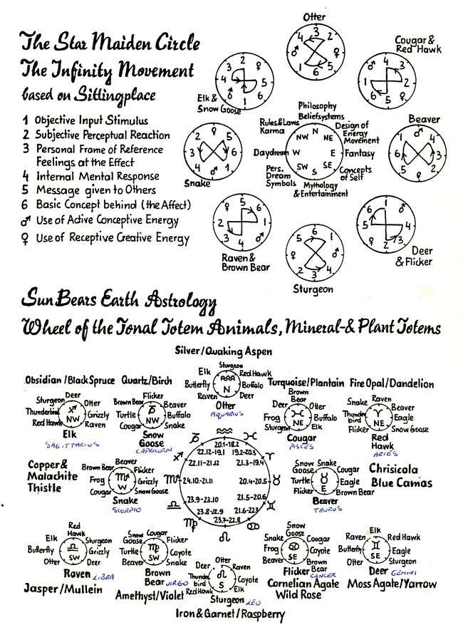
The Sacred Teachings of the Seven Arrows
The sacred teachings of the Seven Arrows are a special gift originally given to us by the Akalohtahey. They are tools which teach us about our concepts of self (who and what we are) and the different ways we can choose to express our energies.
1st Key:
The Bow is the Self; Lower/Higher, Shideh/Hohkshideh.
The Quiver is our Tonal/Nagual resource circle.
The Arrows are our "choice-decisions" of expressing our energy in the process of life.
2nd Key:
Chui-Ta is our needs: it is long term pain for short term pleasure. We must have help to get out of the pain.
Chui-Ka is our wants: it is short term pain for longer term pleasure. We can get out of the pain ourselves.
Chui-Ma is our desires: pure pleasure without pain. It always gives beauty.
3rd Key:
Chui-Ta is our necessary Death experiences.
Chui-Ka is our necessary Life experiences.
Chui-Ma is our necessary Rebirth experiences.
4th Key:
Chui-ta-ka-Ma is our Sacred Choreography, the proper use of all our Energy-Motion-Movement.
The Seven Arrows of the Dark teach us how we get off balance and out of harmony when we get stuck in the shideh's perception of self. The Dark Arrows show us what happens when we define ourselves by the reflections outside of Self and lose sight of the strength and power within. The Dark Arrows keep us in our karma circle.
The Seven Arrows of the Light teach us the ways to be in harmony and balance within the Self. These Arrows show us how true understanding and empowering of Self comes from a focusing on the reflections within the Self: They show us how to cK^nge our karma into dharma.
The Seven Rainbow Arrows teach us ways to create change in our lives, meet our deaths and transform ourselves into the Rainbow Warriors of the Light that we truly are.
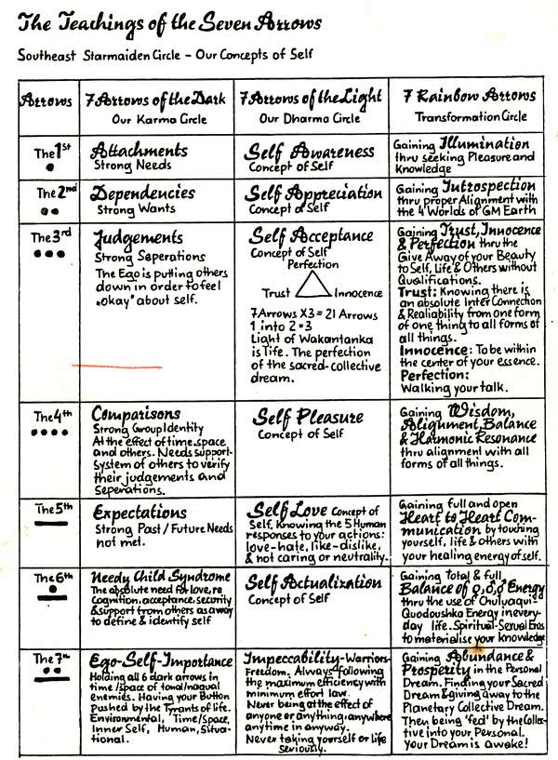
The Twenty Count
The Twenty Count is a way of perceiving the special qualities and "give-away" of the sacred powers of the universe and relating them to the numbers 1-20. This then provides a valuable mathematical system which describes the interrelationships of the powers to one another and forms the basic framework for all of the Sundance Teachings. Further, this system also depicts the connection of the "so below" 1 -10 with the "as above" 11 -20.
The Twenty Count which follows is written so that each of the Powers is to the left in bold while an explanation of what each power is and how each power gives away and touches us with beauty is to the right.
The Power Touches with Beauty by Giving Us:
1) Grandfather Sun - illumination, enlightenment, knowledge.
2) Grandmother Earth - introspection, intuition, love relations, bonding.
3) Sacred Plants - seeking perfection, trust and innocence.
4) Sacred Animals - bringers of harmony and balance, heart movement and alignment.
5) Sacred Humans - determiners of spirit, open hearted human to human communication.
6) Spiritual Ancestors -Tolilahqui (little people). Toushila-Hey (all our personal spirit selves), Tukashshilah (all of the blood relations of our Toushila-Hey), Omitakoyashtn (spirits of all ancestors of all humans on this planet since always, for always), self love, ascended relationships, concepts of self.
7) Symbols of the Dream - process of life itself, experience ot spiritual sexual eros.
8) Book of Life - circle of law, images, earthly family totality of the four worlds of Grandmother Earth, Laws of Cycles.
29 missing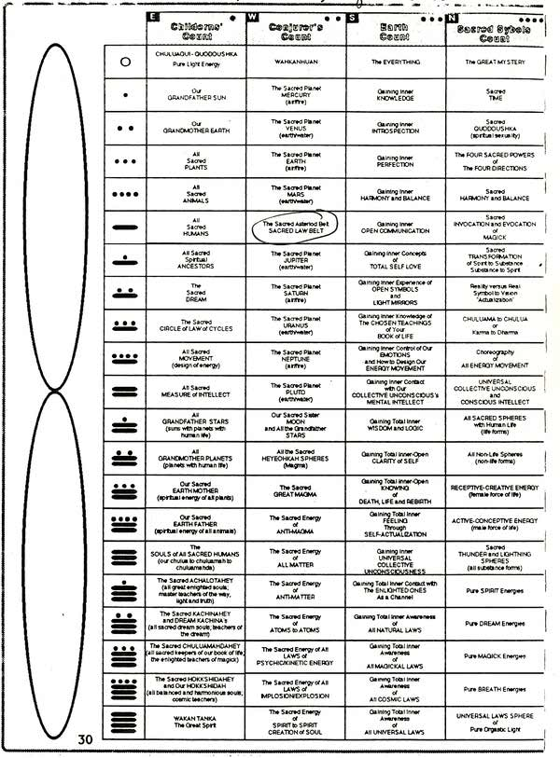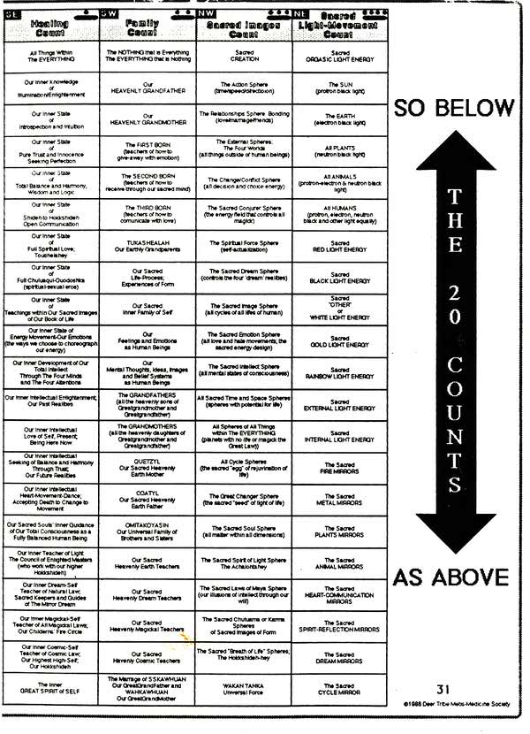
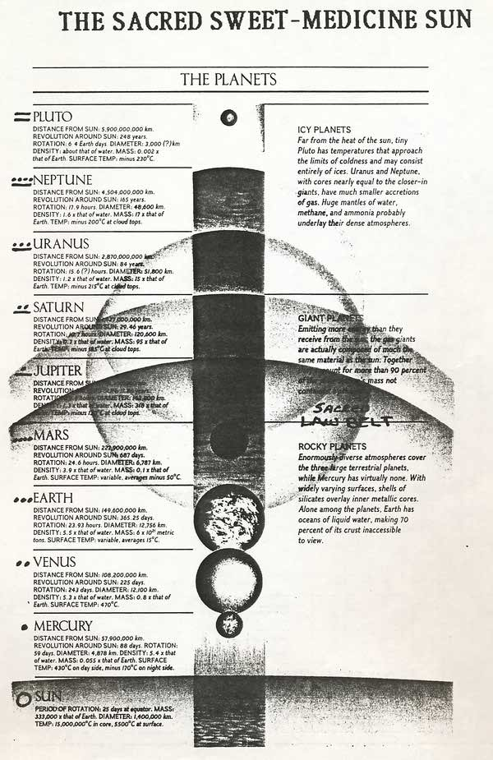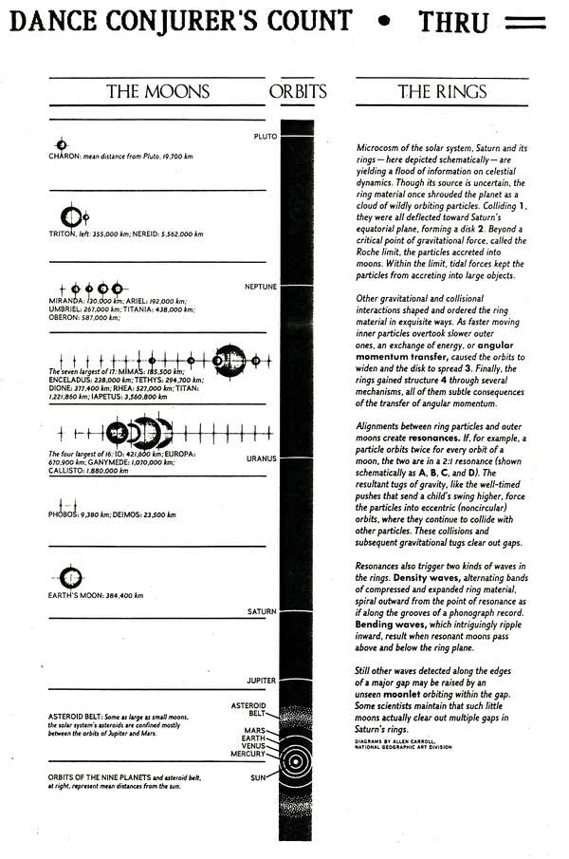

THE SACRED MEDICINE WHEEL
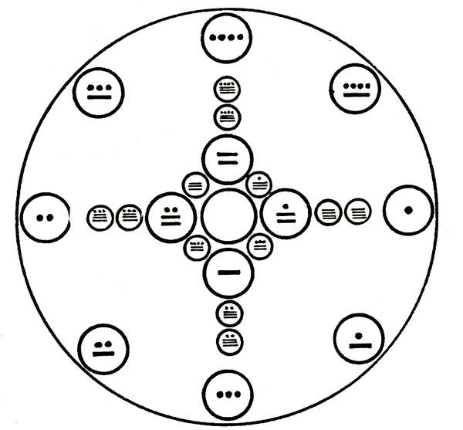
PREPARATION, BLESSING. AWAKENING AND SACRED MEANING
'The Medicine Wheel Is the very way of life of the People. It Is an understanding of the Universe. It Is the way given to the Peace Chiefs, our teachers, and by them to us. The Medicine Wheel Is everything of the People. The Medicine Wheel is the Living Flame of the Lodges and the Great Shield of Truth written in the sign of the water. It is the Heart and Mind. It Is the Song of the Earth. It Is the Star-Fire and the Painted Drum seen only In the eyes of the Children."
(Exert from Seven Arrows. HYEMEYOHSTS STORM, 1978.)
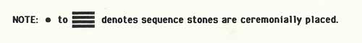
THE SACRED MEDICINE WHEEL
The Medicine Wheel Way begins with the Touching of our Brothers and Sisters. Next it speaks to us of the Touching of the World around us, the animals, trees, grasses and all other living things. Finally, it teaches us to Sing the Song of the World and in this way to become whole people.
"Come sit with me and let us smoke the Pipe of Peace in understanding. Let us Touch. Let us, each to other, be a gift as is the Buffalo. Let us be meat to nourish each other that we all may grow. Sit here with me, each of you as you are in your own perceiving of yourself, as mouse, wolf, coyote, weasel, fox, prairie bird or deer. Let me see through your eyes. Let us teach each other here in the Great Lodge of the People, this Sun Dance, of each of the ways on this Great Medicine Wheel-OUR EARTH!"
(Exerpt from Seven Arrows. HYEttEYOHSTS STORM. 1978.)
______________
The Medicine Wheel is composed of 24 Sacred Stones.
There are eight (8) outside stones which represent the Sacred Powers of the Universe, the Law of Cycles and the Children's Fire, the Sun Dance Circle of Law.
There are four (4) large stones on the inside of the Wheel on the cardinal points which represent the four (4) and twenty-four (24). The 4 Winds, 4 Directions, 4 Elements and the 4 Seasons within the sacred twenty (20), of which twenty (20) represents all that has been, is now, or ever will be, Wakan Tanka, the Great Spirit.
There are a total of eight (8) inside stones which represent our Karma or Sacred Teachings from the Karma Powers. Added to the eight (8) outside stones it totals to sixteen (16) the number of our Enlightened Soul and the Great Avatars or Teachers. /■
There are two (2) stones in each of the four (4) directions which represent our Introspection of Our Path with Heart and also honors the Great Law- "Everything is born of Woman", the two (2) of which total to the last eight (8), to honor the Law-"No law must hurt the children".
The Seven Virtues of a Warrior
Totally open and unlimited imagination which gives us artistic originality.
Deep introspection/intuition which gives us a true refinement of our character.
Complete trust/innocence which gives us the way to properly relate to those people who are in our Immediate everyday environment.
True wisdom/logic which gives the clarity and strength of mind to be spiritually awake.
Honest, open hear to heart communication with ourselves and others which helps us in our knowing the true reality of our physical bodily appearance.
Accepting concepts of our self which guide us in our statements and viewpoints we make in relationship to general knowledge.
Ability to completely open our symbols of the dream experience In order to know the sexual connection we have to all forms of all things within the Everything.
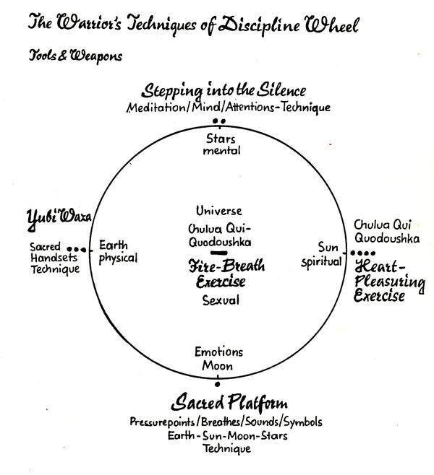
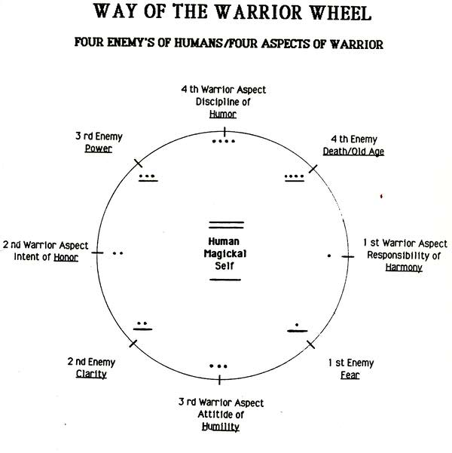
FOUR ENEMIES OF HUMAN'S WHEEL
FIRST: ENEMY OF FEAR
Confronting the Unknown. Our self-love and self-acceptance must be confronted as well and the enemy is always defeated by "Staying-in-The-Now". With the Responsibility of Harmony, we reach Balance.
SECOND: ENEMY OF CLARITY
Confronting Life's experiences in the Dream. We tend to only "see" whatever symbols "verify" our "view" of our life's process. Through the Intent of Honor, we learn to honor our Dance "changes". We "open" our symbols in order to Honor the Self.
THIRD. ENEMY OF POWFR
Confronting our "Images" of "Karma". We tend to see Karma as a debt instead of as a teaching. By learning to develop the attitude of humility, we can learn to never take ourselves seriously. We can laugh at our mistakes and learn from them. Then we can truly "Take-Our-Power" and practice the "Give-Away".
FOURTH: ENEMY OF DEATH AND OLD AGE
Actually confronting the process of our Life's movement toward Death. We don't wish to look at the fact that Death gives Life, Change is inevitable, and Change is Movement. Change, Death, Movement are all the same and that is the Life process. Through assuming the Discipline of Humor, we can gain the Movement of our Higher Self and dance the Dance of Joy meeting Old Age and eventually our Death with a sense of humor.
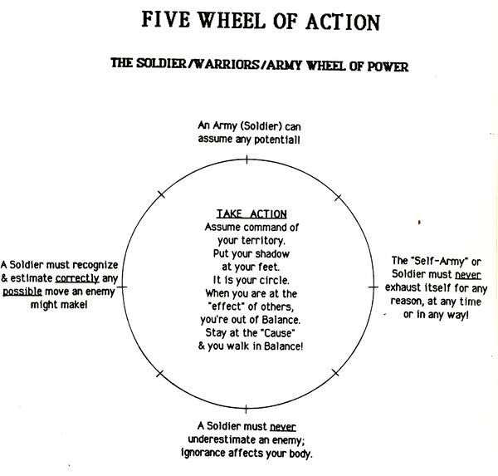

WARRIORS PATH TO THE "FIRE FROM WITHIN"
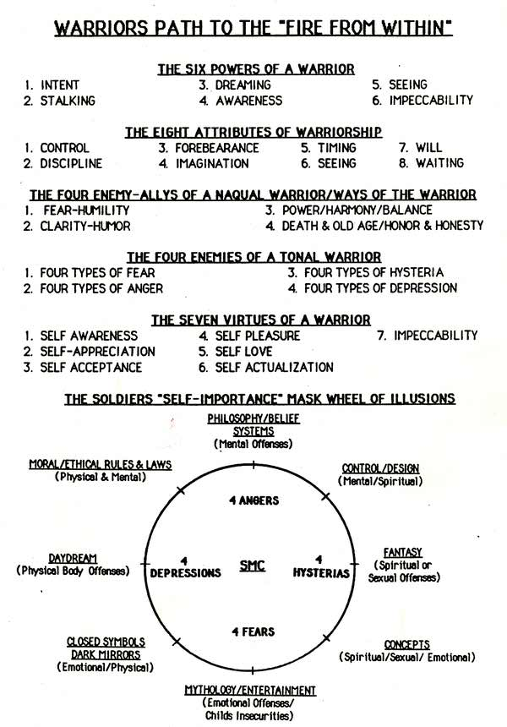

The Human Flowering Tree of Life
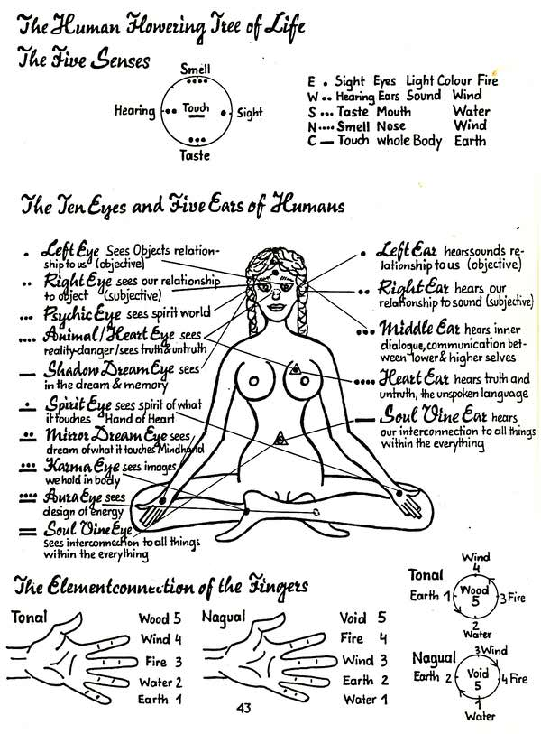
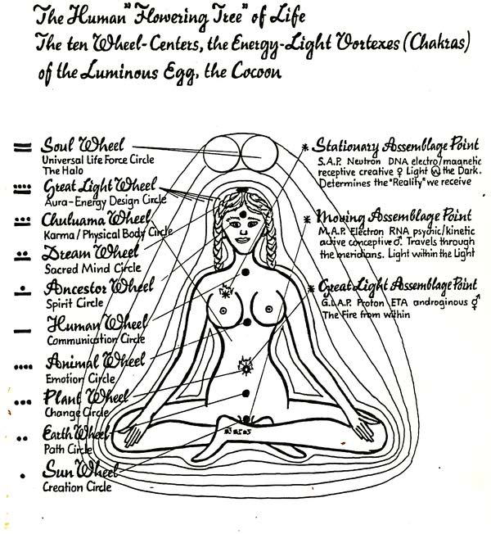
The Human Assemblage Point
There are three Human Assemblage Points. The Static Assemblage Point (SAP), the Moving Assemblage Point (MAP) and the Great Light Assemblage Point (GLAP).
The Static Assemblage Point (SAP)
The Static Assemblage Point is a focal point of energy within the aura whose function is to govern how we perceive our reality. In a sense, it is like a radio or T.V. tuner whose position in the aura (or particular station that it Is tuned to) determines how we perceive reality. For example, when it is centered in the navel, we are open and enlightened, able to perceive our oneness with the Everything and we feel our unconditional love for everyone. From this position we can assemble any reality.
When it is positioned in the right chest area, our perception becomes more narrow and separate. When it is situated in the central chakra line, however, we can begin to really develop the larien.
When we are first born, all three assemblage points are localized in the navel. We are in a place of harmony and alignment with the universe and we completely know our oneness with the Everything. Over the course of the next three years, the Static Assemblage Point begins to move up the chakra line and becomes situated in a predetermined position somewhere in the right chest area. In fact, this position is determined by each of us before our birth to enable us to perceive reality in a way best suited for the specific growth and experiences we need from a particular life.
Once stationed In the right chest area the SAP is essentially in fixed position, but this position can be shifted. In fact, it is desirable to shift this assemblage point to center and back down toward the navel. It can be temporarily shifted in this direction by crystal shifting, third and fourth level orgasm, chanting, songs of power, meditation and ceremony.
It will be shifted diagonally when working with certain teacher plants and shifted straight down the right side by extreme fear, terror, psychosis and tyrants. This straight down shift will cause a distc. ted view of reality. Of note, in catatonic schizophrenia, the SAP is usually shifted down the right side below the heart chakra line and the condition can be improved if the SAP is reshifted back to its original resting position. In working with the tyrants, even though the SAP will start to move straight down, we can learn to use our will and breath to alter the direction of movement to center and then down. If the SAP moves straight down past the navel, death will occur instantaneously.
There is a gradual long-term movement of the SAP's resting position during life (toward center and then down) as a result of spiritual growth and development and increasing orende levels. The more enlightened and in balance and harmony we become, the more the SAP will become positioned toward the center chakra line and then down towards the navel again. Obviously, frequent temporary shifts through crystal shifting, orgasm, chanting, ceremony, etc. will facilitate the more long-term repositioning.
If a one inch or more shift is maintained for at least a year, then this will become the new resting position of the SAP. If this is maintained for at least three years, then the SAP will never go back up over this.
The Moving Assemblage Point (MAP)
After birth, the MAP leaves the navel and begins to circulate throughout the meridians of the body. It is synonymous to the Ki or chi (described in oriental medicine ) which flows through the meridians in a repeating 24-hour cycle. The MAP holds the physical body together. It establishes the normal cyclical ebbs and flows of bforythms in all five aspects of our beings: The emotional, mental, physical, spiritual and sexual. It Is, therefore, also responsible for creating our natural daily, monthly and yearly energy cycles called "the Naturals". (For a description of the Naturals, see page ).
The Great Light Assemblage Pofnt (GLAP)
The GLAP remains situated in the navel throughout life. It is the point from which we reach out to perceive the Reality Truth of the Universe. The Soul Vine, or Luminous Fibers of the Human Cocoon, are sent out from the GLAP into the Universe to maintain our connection and alignment with the Everything. Through the GLAP, we keep our connection with the Source and with the Womb of Creation. Seen from reverse, it is the point from which the Great Spirit assembles us, as parts of its innumerable points of perception. In a sense, it could be said to be the transmission line between us, as humans, and the Source of the Force ( or Source of the Everything). It is where we can perceive all realities with all the worlds and all the Universes withing the Everything.
When, as a result of our spiritual growth and development, we become rully enlightened, then the SAP becomes positioned the in 3rd chakra along with the GLAP. Now our perception of reality and the Great Spirit's perception become one. Thus we can truly see through the eyes of the Great Spirit all time, space, dimensions and realities.
The Human Shields
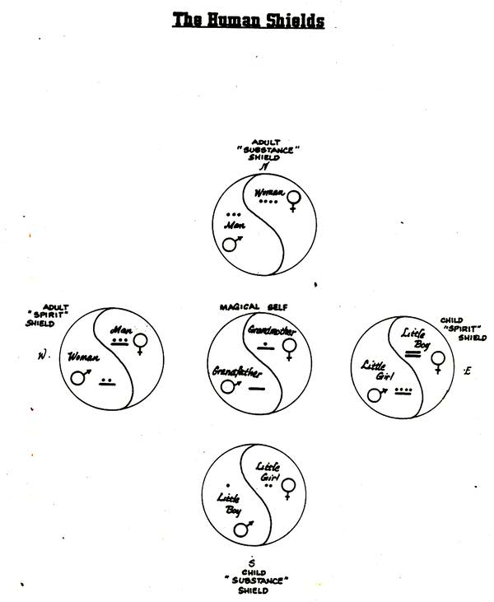
The Shields' Basic Needs
NEEDS, WANTS, DESIRES
Needs: If a person does not have it, he/she will suffer long term pain and will not be able to get out of the situation without external help.
Wants: If a person does not have it, he/she will usually suffer short term pain, but will be capable of extracting himself from the situation eventually without help.
Desires: Something a person is not attached to; he/she will walk in beauty with or without it.
The key to enlightenment is to make our needs into wants and our wants into desires.
Every shield has basic needs: emotional, mental, physical, spiritual and soul.
Child Substance - South
Emotional: Needs acceptance, love, support from peers, and parents and significant others.
Mental: Need for constant acknowledgment.
Physical: Need to explore body, find out about orgasticness and to explore how he/she relates to all of the environment.
Spiritual: Needs absolute ability to explore without boundaries.
Soul: Needs cohesion.
Adult Substance - North
Emotional: Needs to know it is worthy to others; that it is loved and is worthy of love; needs acceptance from peers.
Mental: Needs to be able to explore knowledge when it. is ready for knowledge.
Physical: Needs to choose its sicknesses as teachings in order to learn how to feel its body. Needs to have open explorative sexuality with the opposite sex in order to discover Its own sexuality. Men learn through actual sexual contact; women can learn through companionship, relationship and support.
Spiritual: Needs to be able to examine the interrelationship with different aspects of itself; how it interrelates with what is around it. It is beginning to shape its reality.
Soul: Needs to disintegrate - be able to tear things apart just so it can put them back together.
Adult Spirit - West
Emotional: Needs to seek love and acceptance with same sex.
Mental: Needs absence of belief system; needs total abandonment of belief systems.
Physical: Needs an open and unlimited sexual circle; needs to be able to make that choice: celibate, monogamous, triadic, expanded, or polygamous freely.
Spiritual: Needs a totally open and unlimited Imagination.
Soul: Needs to give to others with whatever It has to give, unconditionally, with no attachments or expectations.
Child Spirit - East
Emotional: Needs to give love unconditionally.
Mental: Needs to share everything it knows. (Mr. God. This is Anna - Flynn)
Physical: Needs to heal others by healing themselves. Spiritual: Needs to find the light and go toward it.
Soul: Needs to have a totally open and unlimited circle of being.
Grandfather/Grandmother - Center
Needs light through the breath of light in harmony and balance.
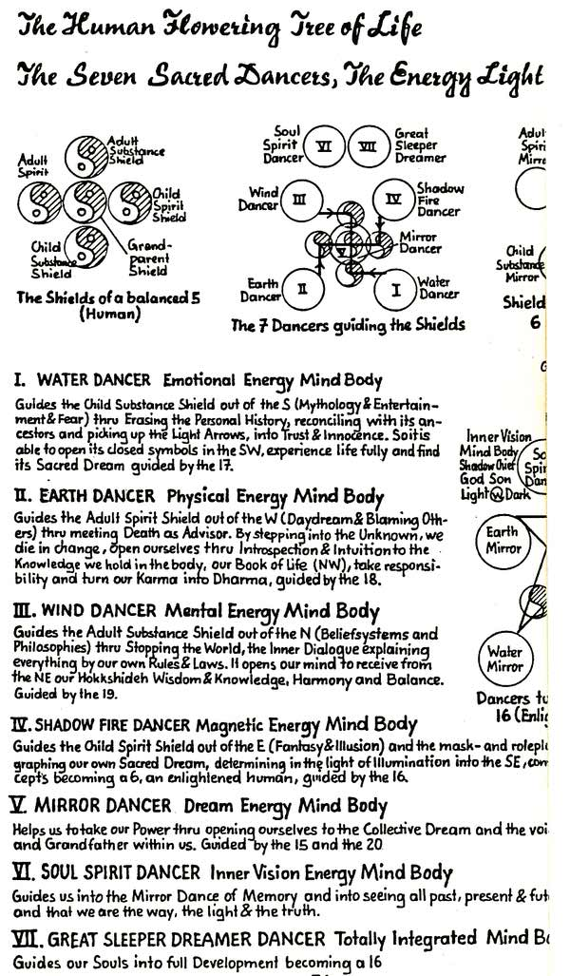
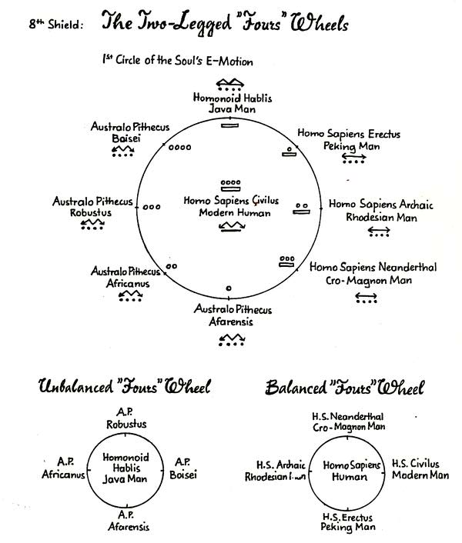

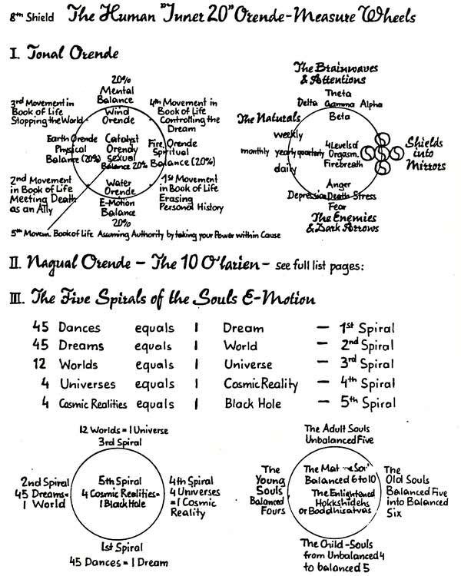
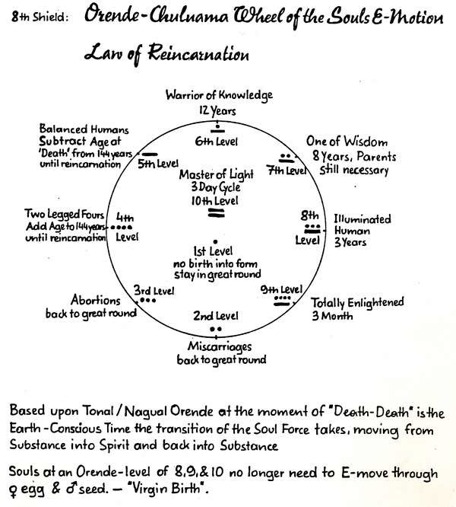
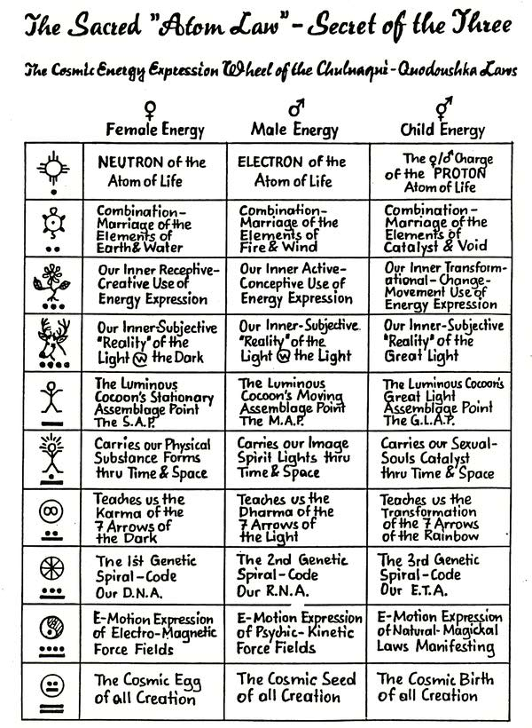

Seven Dimensions of "Reality" Wheel
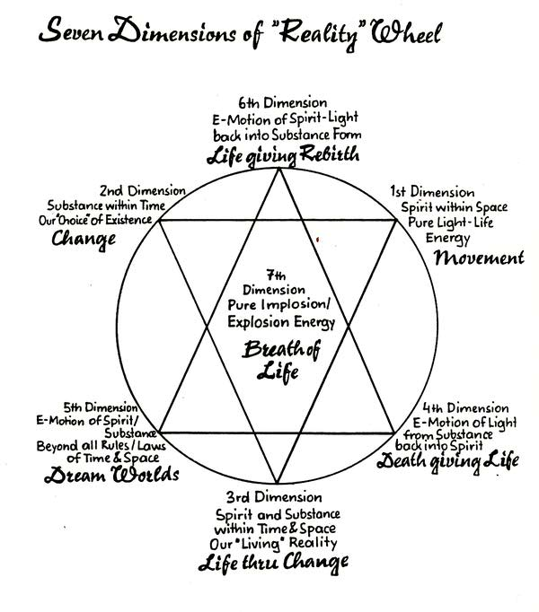
Orende Levels
Orende is the overall energy and vibration of anything in existence, including human beings. Orende levels are not static and will change depending on our process in life. Although the average orende level at which most humans function is between 2.3-2.6, a fully awakened human functions at a level of 5 or above. In our interactions with others, we follow the orende laws of cohesion, adhesion or repulsion depending on the difference of orende levels between us. If the energy difference between two individuals is + or -1, they will interact with a cohesive energy. If It is + or -2, they will have an adhesive energy and if it is greater than 2 they will experience repulsion. In this case, usually the higher orende indiviual will experience an energy drain and the lower orende person will experience a sense of neediness and clinging to the other. If one pays attention to these laws, and chooses partners who are less than two degrees different, then the relationships will have more harmony and balance on all levels as well as have much more compatability sexually. It is important to realize that sometimes there is compatibility in some areas and not in others. For example: Two people may have very similar sexual orendes and thus have a great time in bed, but very different emotional, mental and spiritual orendes and thus not really be able to get along in these other areas. Furthermore, two may come together at the start of a relationship with similar orende levels but their growth processes may change at different rates and, thus, after some time, they find each other with very different orende levels and quite incompatible. Several methods to increase orende include: ceremony, chanting songs of power, meditation, orgasm, developing our larien, proper diet and following the naturals.
Calculation of Orende Levels
The mean orende level is made up of the average of spiritual, mental, emotional, sexual and physical orende levels. A rough estimate can be obtained in the following way:
1. To calculate spiritual (naqual) orende: read through the descriptions of the 10 larien. (Not Included in this manual). Your orende level for each larien is the highest level you can hold 50 % of the time. Write down the number for each larien and divide by 10. That Is your average spiritual orende.
2. To calculate mental, emotional, sexual, and physical (tonal substance) follow the chart below. Your orende level for each is that number that accurately describes your needs.
 | Several  Times/Day | 1-2 Days | 3-7 Davs | 7-14 Days | 1-2  Months | 3-6 Months
Need Tor MENTAL STIMULATION | -------- | 5 | 4 | 3 | 2 | 1
Need for EMOTIONAL NUTURING | 1 | 2 | 3 | 4 | 5
SEXUAL  DESIRE | ------ | 5 | 4 | 3 | 2 | 1
 | 1 Meal  4-5 Hrs. Sleep | 1.5 Meals  5-6 Hrs. Sleep | 2 Meals  6-7 Hrs. Sleep | 2.5 Meals  7-8 Hrs. Sleep | 3 Meals  8 or more Hrs. Sleep
PHYSICAL need for FOOD & SLEEP | 5 | 4 | 3 | 2 | 1 | ------
Add up your orende level for spiritual, mental, emotional, physical and sexual and divide by five. The number you obtain is your mean orende level in the tonal substance world.

The Naturals

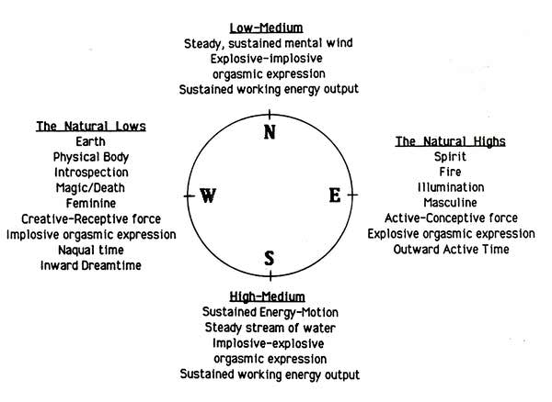
"The Naturals" Is a system which describes the normal ebb and flow of energy cycles within our beings. By working with our own Naturals and designing our energy movement in harmony with our natural flows, we are then able to Increase our overall energy level and bring into our lives that which we desire. There are daily, weekly, monthly, and yearly "natural" cycles of energy movement in which there are periods of low, low-medium, high-medium and high energy.
The Natural Low Energy Times
These are dream times, naqual times and times to pull In from activity and go Into the "creative-receptive" or "feminine" mode. During our lows, It Is important to nurture and nourish the physical body through food, drink, relaxation, meditation or sleep. There may also be things within the alchemy of the four elements and four worlds that can bring us power during these times. We must always honor our natural lows. If we overextend or push our energy during the low times, then our medium and high cycle energies will drop and our next low will be even lower. The low energy is like the energy of the west, the place of the earth, introspection, magic and death giving life. It Is the Implosive orgasmic aspect. As it is earth, we must be careful to hold the physical energy In balance during these times.
The Natural High Energy Times
This energy is opposite to the natural lows. This is a time of bursts of activity In the tonal with little desire for food and sleep. We must give deference to this period too, as there can be a tendency to over do with resultant burnout and energy decrease in the rest of the cycle. This high energy is like the energy of the East, the place of fire, illumination, the active-conceptive force and the explosive orgasmic aspect.
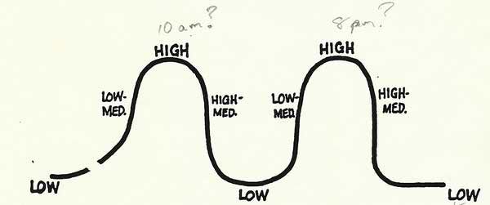

The Natural Medium Energy Times
These are times of sustained working energy output. We have a low-medium energy time in the north with a steady mental wind element and the explosive-implosive orgasmic aspect. We have a high-medium energy time in the south with a steady stream Energy-Motion.
The 24-Hour Natural Cycle
Each 24-hour period has two full energy cycles within it and, as such, can be considered to be like two complete days. The exact timing of these energy cycles is specific for each person, but there are general tendencies which most people seem to follow.
Usually, sometime between first awakening in the morning and early afternoon, each of us will experience a minor low. As described previously, this is an interval for rest and nourishment. Then sometime between 3 and 7 p.m., most of us will experience a major low. This may last longer (between 1-2 hrs.) and be more severe than the minor low, so it is imperative to nap and eat. We then experience another minor low sometime during the evening and a major low later on which is what prompts us to go to sleep for the night. In between each of these lows is a low-medium, high and high-medium energy time as already described.
Our highs and lows will tend to occur at very similar times during each day. These energy times should be mapped out so that we can work with them appropriately. With time, the iows will get higher.
The Weekly/Monthly Natural Cycle
Within every four week period, each of us experiences a low, low-medium, high, high-medium and then low week again. While this is the most common pattern, these energy weeks can occur in any order. Again, it is very valuable to handle each of these weeks by arranging more rest time during the low weeks, etc. Note that during a low week, it is even more important to honor the low times in the daily cycle.
The Yearly Natural Cycle
During every yearly cycle there are four seasons: one low, low-medium, high and high-medium. If we look at the natural energy of the seasons, winter Is most akin to earth, summer to fire, spring to wind and autumn to water. Not everyone will experience them In this way, so again we must determine what is true for each of us. We then can plan our lives in such a way as to take into account the energy of each quarter.
Planning and Dreaming for the Four Quarters
The next aspect of the Naturals involves actively dreaming and creating our lives In accordance with our own energy movement. This is a very powerful process which helps to sharpen our skills as dreamers and helps to connect us Into our Hohkshideh's higher plan. By writing down and formulating our dreams In this way, we create the alchemy necessary to set Into action the electro-magnetic vortex which then pulls energy towards It, thus helping to actualize the dream Into physical reality.
To prepare for planning out the year, It is best to do so In a ceremonial or meditative space so that we can connect into our higher selves, accurately tune into the energy flows and thus create, in harmony, with the energies at hand.
When we first set up the Naturals In, this way, we need to plan out all four quarters (seasons) of the year. Then, at the end of each quarter, at the equinox or solstice, we can evaluate the quarter that just passed, add any new plans and dreams to our remaining quarters and finally create a new fourth quarter so that we are always working with a full yearly cycle. It is beneficial to do the revising around the equinoxes and solstices because these are special energy times. These are transitional moments between time and elemental Influences ideal for choreographing our new dreams.
The equinoxes fall on the 21st of December, March, June and September. The four seasons are as follows:
Winter: December 21-March 20
Spring: March 21-June 20
Summer: June 21 - September 20
Fall: September 21-December 20
TO CALCULATE QUARTERS
1. Take four pieces of paper.
2. At the top put the dates and names of each season starting with the one in which you are at present.
3. Under this write the special name given to each quarter from the warriors wheel; i.e.:
Intent and Control (having complete control and focus on that which you wish to accomplish)
Dreaming and Discipline (one step away from Immediate; this is active dreaming with discipline)
Stalking and Forbearance
Timing and Awareness
These describe the most appropriate way for each of us, as warriors, to approach our dreaming for each quarter. The quarter we are always presently in is Intent and Control. Thus at the end of each quarter, the names will rotate. By the time four quarters are complete, each of the new quarters will actually have four names (in different order). This shows us the importance of each warrior quality for creating our dreams.
4. Now split each piece of paper into:
Tonal | Naqual (spiritual growth and dreams)
Mental
Career
Emotional
Physical Sexual
5. Next begin to fill in the dreams and desires for each of these. As you do so, be as specific as possible. For example, don't just ask for money. Put down all the specifics of what you want the money for and focus on getting these. s
6. The value in having the different headings for the tonal dreams is to make sure that our lives are full and that all aspects of our beings are satisfied. Other headings can certainly be added to these if desired.
7. When plotting and planning each quarter, take into account where your energy will be In each quarter and create things suitably.
8. Also, pre-plan the steps along the way to the actualization of a particular dream. I.e., If you are planning a move in your career which you forsee actualizing in three quarters, you may want to see yourself meeting certain Influential persons in the earlier quarters or getting a job that you know is a stepping stone toward that goal.
9. The more specific details you write for each dream - the better.
10. Once you have written your plan for all four quarters, create a ceremony in which you pray out loud for each of your dreams and then give them away. (Traditionally, this was Is done In a sweat lodge. If you do not have access to one, you can create your own ceremony.
This is an extremely powerful process for taking control of our lives. Give it the attention it deserves. Once these Naturals are set into action, don't let them slide. If you stop dreaming there will be a void in your energy creation and your life may start falling apart. Be disciplined and keep creating and dreaming and dreaming...
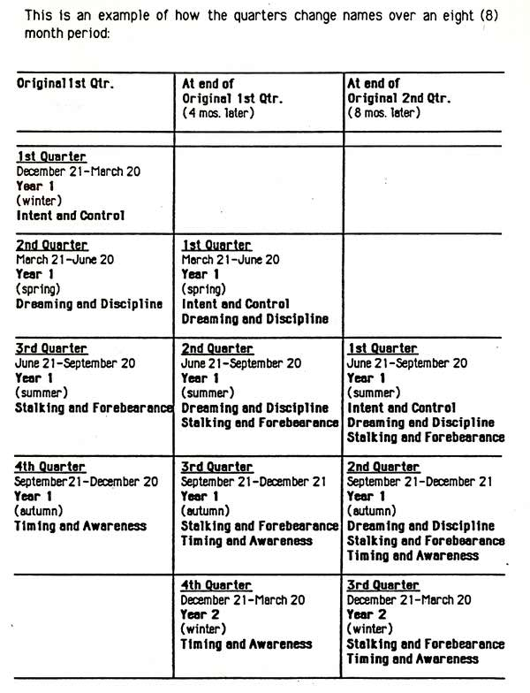

Sacred Platform
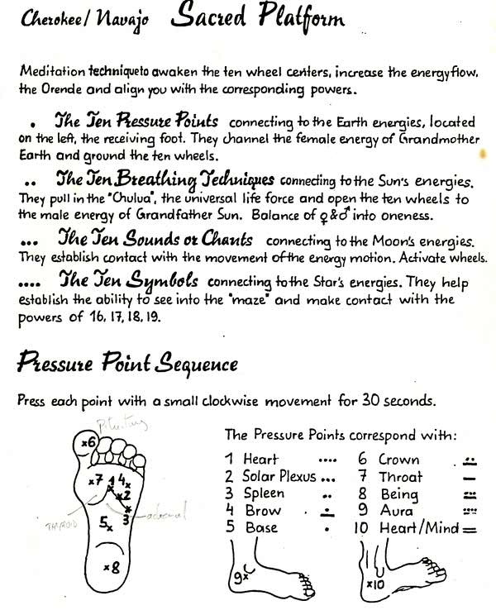

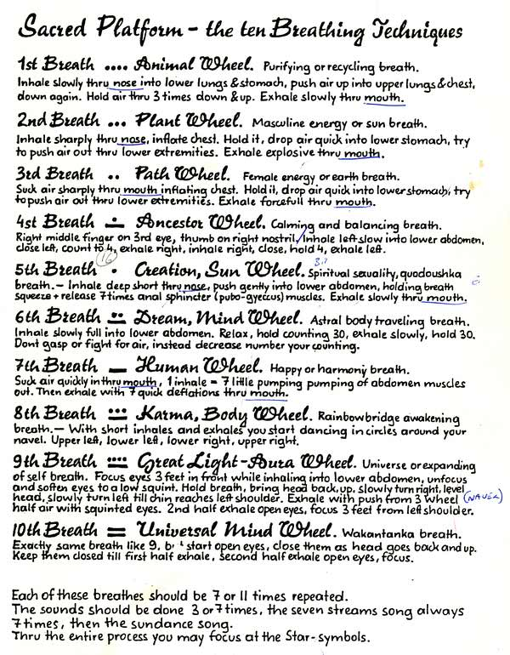
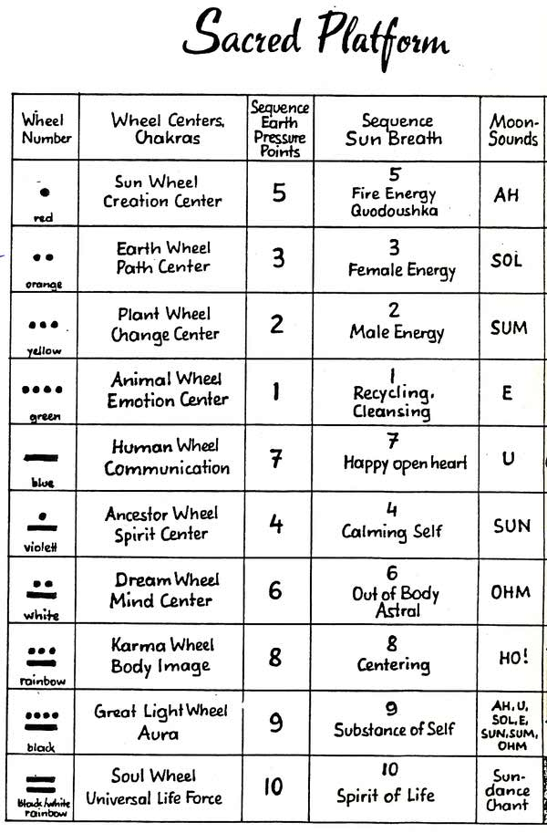

The Human Wheel of "Love" Relationships-Choices
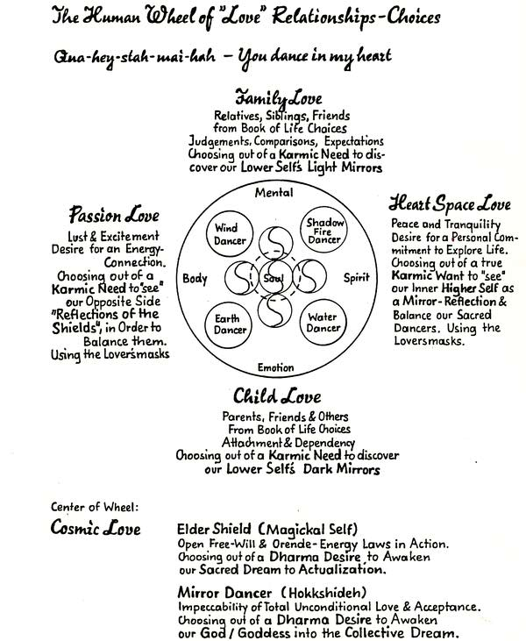

Tyrants Masks Wheel of Power
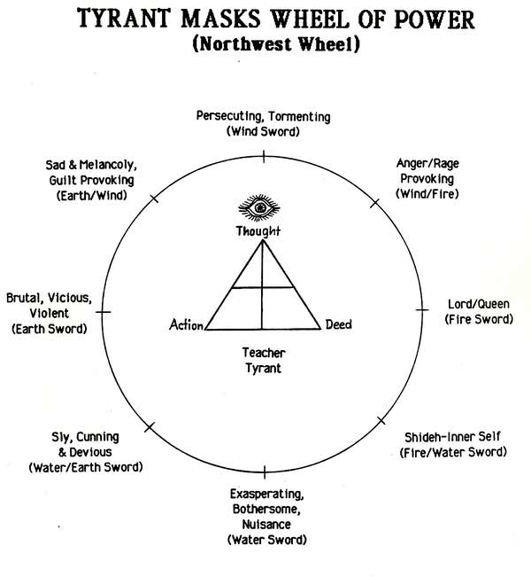
The Tyrant's Masks
The Tyrant Masks are the nine different aspects of ourselves as tyrants for others as well as the different types of tyrants that others can be to us. Learning to work with these can be an extremely valuable process for gaining more power and control within the self.
The South Tyrant
The exasperating, bothersome, nuisance tyrant Is irritating, petty and seems to be always present and in the way. These tyrants will often come over uninvited and overstay their welcome. They seem to have very poor timing and not to be consciously aware of what they are provoking in you. They use the water sword to get to you through your emotions and hit your mind.
Count coup through: emotional discipline
The Southwest Tyrant
The sly, cunning and devious tyrant Is the master manipulator. Usually out for themselves they will manipulate to get what they want Lovers and children often do this also. They use the water/earth sword to get you to react physically by getting over-emotional.
Count coup through: emotional dlsipllne and control of the physical space
The West Tyrant;
The brutal viscious and violent tyrant uses physical violence to get their way. They use the earth sword to go through the physical body to break the spirit and possess the soul.
Count coup through: control of the physical space
The Northwest Tyrant
The sad, melancholy, guilt-provoking tyrant works through our morals and feelings i of right and wrong to make us feel guilty. The old: "If you love me then you will...". I They use the earth/wind sword to possess our body through our mind.
Count coup through: control of physical space and mental forebearance
The North Tyrant
The persecuting, tormenting tyrant works through our philosophy and belief system by putting other ways down and by disrupting our originality and artisticness. They use the wind sword and work through the mind to hit our emotions.
Count coup through: mental f orebearance
The Northeast Tyrant
The anger-rage provoking tyrant pushes all our buttons and then keeps going. They use the wind/fire sword and work through our mind to get to our spirit.
Count coup through: mental forebearance and timing.
The East Tyrant
The Lord or Queen Tyrant will kill to rule. They work through our spiritual beliefs and fantasy to possess us. They want domination of our entire circle. They use the fire sword and work through our spirit to control our bodies.
Count coup through: timing.
The Southeast Tyrant
The Shideh-Inner Self Tyrant Is our own Inner concepts of self. The major tools of this tyrant are the seven arrows of the dark: Attachment, dependency, judgment, comparison, expectations, the needy child syndrome and self Importance. This is how we use our fire/water sword and work through our spirit to disrupt our emotions.
Count coup through: timing and emotional discipline.
73 missing
DANCING IN THE DREAM MEDITATION
Control of the "Waking Dream" by learning to control the "Sleeping Dream" In order to have more control over processing Symbols within our Life Dance.
• Place two owl feathers above your bed to receive introspection of the Dream from the owl, who Is the "bringer" of the Dream from the Kachinas (Keepers of the Dream) to Humans in their Dance (Life).
•• As you go to sleep at night (or In the "Day Dream") give your "Higher-Self" the self command: Tonight I will "Dance In my Dream".
••• Go to sleep and wait until you begin to experience the phenomenon of being asleep and dreaming-but are aware that you are dreaming. Your "sleep-self" is aware that the "dream-self" is experiencing a "dream". At this point you are ready to begin to "Dance In The Dream".
•••• From the consciousness of your "sleep-self" give your "dream-self" consciousness the command: I am now going to Dance with this Dream. Then "split" your attention. Focus Into the 1st and 2nd attention states of awareness.
••••• Once you have "split" your two attentions, you will command the "dream-self" from the "sleep-self" to go and seek Its reflective Image, I.e., the "dream-self" must go "look" into a mirror, pool of water, window, etc. and gaze into this reflection of self to gain control of the "dream-self". At this point you will be able to take control and move out of your body Into the astral or ethereal projected self.
•••••• Now "release" your spirit into the "dream-self". Whenever you are experiencing a dream from the frame of reference that you are viewing yourself on a T.V. or video-tape like process, you are in a "Pseudo-Dream". In this "standing outside watching yourself" type of dream you are extremely susceptible to the dream imposters! Frequently we look like ourselves or someone we "know", but do not act like we do or how we know the "others" do. Therefore, you must gaze into the reflection and immediately transfer your "spiritual consciousness" into the "dream-self". At this point you shift focus so your primary awareness now is you as the "dreamer" within your dream. You will be actually "in" the dream and not just viewing it. From this type of dream you can maintain control and guide your lower-self by learning of higher teachings from within the true "dream-self".
••••••• Having moved into the context of the Dream, go to your Power Spot and ask the Universe to send you a Dream Teacher of the Light. Dance the Dream, Seek Knowledge and TAKE YOUR POWER!
76 missing

HOW TO TOUCH LIFE AND OTHERS WITH YOUR BEAUTY.
WHEELS AND KEYS FOR HEALING OTHERS

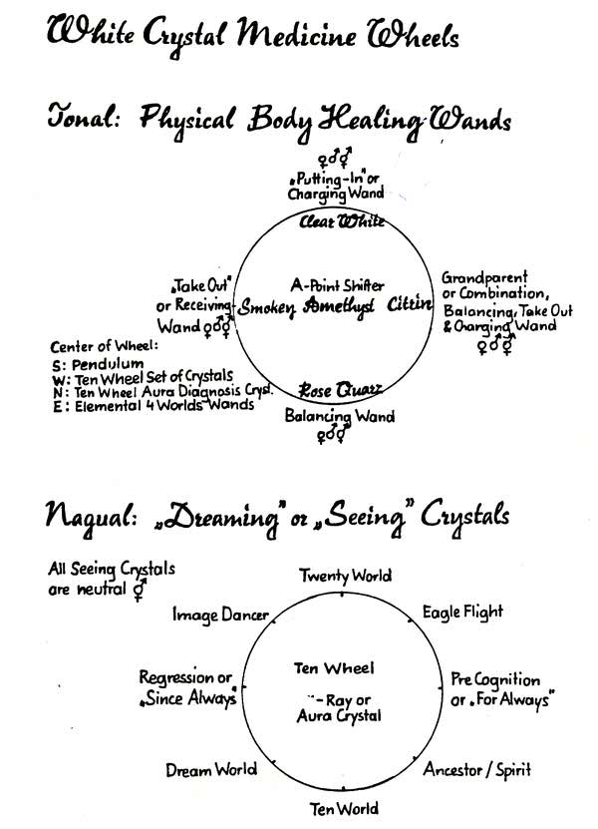

78 missing
examine the modern day use of crystals we see medical science and science technology using the crystals the same way the Native American uses them. How? The crystals are the holder/determiner of energy, therefore they are the great choreographers.
Most of the teachings in the Native American world, especially those of the Sweet Medicine Sundance Council, are in the form of wheels (since there is no such thing as linear movement or linear logic, for straight lines do not exist in the macrocosm or microcosm). The Native American people clearly understood the use of the circle and the concept of zero. Therefore the teachings of the Native American people are in the form of a wheel, to show the interconnection, interdependence, and the interreliability of one form of one thing to all forms of all other things within the great and sacred space of the everything, which we call the Great Spirit All forms of all things that exist are manifested within the four elements of fire, earth, water, air, as they come out of the void, or the space of the everything, which we call the Breath of the Great Spirit
Before we delve into the utilization of healing crystals, we must first understand that we as humans, the determiners of energy, are taking full responsibility for what we will do with the crystal, and how we will apply it within the great sacred natural, cosmic, and universal laws. We sit and hold the crystal in trust and innocence, for they are like children when used in accordance with the sacred laws. Crystals are our connection from the first chakra to the tenth chakra, therefore we should adapt and assume an attitude of responsibility, alignment and connection.
The "give-away" of any karmic connection we might have to our client or patient is essential, when working with healing crystals so we do not step into the patient's free will circle. The more common approach to Native American healing begins by recognising that the patient chooses their disease as a way of learning about life, therefore they must take responsibility for the disease. In essence the Medicine man or woman heals no one, instead they are an energy dancer, who choreographs, designs, and determines how to do oroper evocation (calling of the lower powers), invocation (calling of the higher powers), and a proper conjuring (the marriage of the upper and lower powers as one power). The Medicine man/woman shifts the energy to put the patient into their higher self, get them in contact with their ancestors and in touch with the Great Spirit It then becomes the patient's responsibility to see how and why they have chosen the disease in the first place, and be able to give it away.
PRACTICAL USE OF HEALING CRYSTALS
When referring to "healing" or "doctoring" crystals we are relating primarily to physical disease sickness. In reference to "dreaming" or "seeing" crystals we relate to spiritual self development practice. We will begin with "tuning a crystal". This is a technique employed to bring about harmonic resonance, which is the vibration of the human in alignment with the vibration of the crystal There are numerous ways to accomplish this. The following is one method:
1. Hold the crystal on your right hand
2. Touch the point to the palm of your left hand
3 . Move the crystal out about one and one half to two inches from the palm
4. Rotate the crystal slowly clockwise, keep doing so until
5. You feel an energy shift, i.e. such as a screw being tightened into a hard piece of wood and gradually feeling maximum resistance. Stop, this will be an indication of alignment taking place.
Of the five types of crystals, not including the ten wheel diagnosis, a crystal may be either neutral, male, or female. This refers to the energy rotation at the tip of the crystal. Using a pendulum, if it rotates clockwise it is a male energy or active conceptive seed crystal Rotating counter clockwise it is a female energy or receptive creative egg crystal If it is neutral it will swing vertically or horizontally, that is up or down, left or right. The reader should be cautious, however in determining through the use of a pendulum proper rotation of a crystal due to their own mental influence over the pendulum. Approximately eighty percent of Grandmother earth's crystals are neutral, about ten percent masculine, and ten percent feminine. If pendulum checking does not match, it is advisable to construct a pendulum on a neutral stand, or execute electromagnetic testing on a crystal
The following is a brief description, and application of each crystal on the Healing Crystal Wheel:
In the East; combination/grandparent
In the West; take out/ receiving
In the South; balancing wand
In the North; putting in/ charging
In the Center; assemblage point shifter
East of center; elemental four world wands
West of center; ten wheel set
South of center; pendulum
North of center; ten wheel diagnosis
BALANCING WAND (neutral)
Characteristics: One triangle at the tip, better if two that merge and go to the central point or blade. All balancing done preferably with the right hand, regardless of left or right dexterity (keeping in harmony with the body polarities, left side receiving, right side giving). The balancing wand is used for exactly that purpose, to balance the ten chakras of the human being.
TAKE OUT/RECEIVING (neutral)
Characteristics: Flat sloping face about forty five degree angle, one perfect triangle going up the opposite side of the sloping face.
Basic Procedure:
Executed with the left hand using the take out face, through the medium of breath technique, short inhales via the mouth as though sucking, take out at the chakra point, or through the left or right foot, left or right hand( left side of body cause, right side of body symptom).
PUTTING IN/ CHARGING (neutral)
Characteristics: Two, preferably three perfect triangles with no clouding.
Basic Procedure:
Executed with the right hand, through the medium of breath technique, short exhales via the mouth as though blowing, touching the area to be charged with the crystal, which will usually be the fingertips, or energy meridians, or chakra point itself.
COMBINATION/GRANDPARENT (neutral)
Characteristics: Three perfect triangles are absolutely necessary and a take out face. Included as many amplification features as possible such as arrows, phantoms (elevate the energy ten to the tenth power or a thousand percent), needles, ridgelines, blades, diamond pattern in faces, inner pyramidal constructions, mirror pyramidal constructions (which come about do to a reflection of light from one or more faces).
Basic Procedure:
Ability to balance, charge, and take out
ASSEMBLAGE POINT SHIFTING CRYSTAL (neutral)
Characteristics: A rounded base, average length, two and a half to three inches. Circumference; at its widest point one and a half to two inches. Perfectly clear, no clouding. Combination/grandparent, putting in/charging, or a balancing wand preferred, definitely not a takeout/receiving.
First choice: Combination/grandparent
Second choice: putting in/charging
Third choice: balancing wand
Basic Procedure:
Shift the Assemblage Point (indepth explanation is not possible in this chapter due to limited space).
PENDULUM (previously discussed)
TEN WHEEL SET (neutral)
Characteristics: Ten crystals graduated in size, the first being the smallest, the tenth the largest Aura of each crystal matches the color of each chakra.
Basic Procedure:
Employed in very serious healings. Crystals are placed on the chakras, point up, to expedite the energy charge being given to the body. Rotating clockwise, points down, assist in releasing negative energy. Applicable for charging, taking out, and balancing.
TEN WHEEL DIAGNOSIS (neutral)
Characteristics: Traditionally calcite, shaped like a parallelogram.
Basic Procedure:
Passed over the chakras to see or dignosis what imbalances are occuring from the organs that are guided and controlled by that chakra.
ELEMENTAL FOUR WORLD WANDS (neutral, charging, grandparent)
Characteristics: traditionally constucted from mineral, plant animal, or human world. Not recommended, copper, iron or lead, they are improper conducters for physical healing. The stem of the wand is constructed from one of the four worlds, or all four united. The crystal is connected or attached to the stem, hence an elemental wand.
Basic Procedure:
Exercised in serious healings, when invocating, evocating, and conjuring. To come into alignment with the four worlds, using that particular world and crystal (construction of your wand), to generate a double energy.
Additional key information;
Crystals hold and flow energy when used in healings, otherwise they may shatter from the overload. Each person needs to choose a crystal that fits in the hand comfortably making contact with the palm and gripped by the thumb and all four fingers. The tip of the crystal extending beyond at least an inch from the hand.
Basic cleaning and care of crystals; best to wrap in soft red cloth, i.e. velvet felt etc... Wash in salt water and smudge them with sage. To smudge, burn a small amount of sage in an abalone shell and hold crystal over the smoke, point up and down.
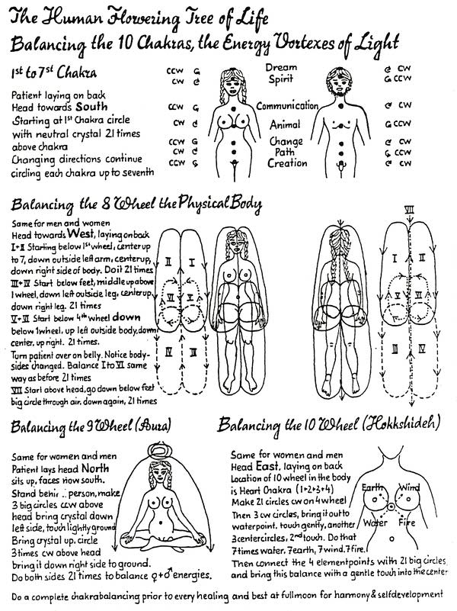
STEPPING INTO THE SILENCE
A. Starting at feet, have patient go "DOWN" with their mind and place FULL CONCENTRATION into their feet, relaxing them untill they feel heavy or melting. Direct them to give a "Self Command" to their feet that "No more signals shall be received from feet for movement."
Feet are now totally relaxed.
B. Repeat same procedure, gradually moving up the body. Take time-don't rush it
C. Spend time on eyebrows and eyes in particular; then have them focus UPWARD while eyes are closed and focus on their 7 wheel.
D. Have patient hold their eyes in that position for full count of three and when they are looking up-simultaneously have them gently yet firmly open their eyes. (Command it).
Now command them to relax and "DROP" and they enter second level consciousness.
E. Count backwards slowly from 10 to 1, stating that each number deepens them into their Magickal Self. When you reach one, announce that they are at the center of their self, one with the Universe. Command that they "TAKE POWER, BE HEALED, ARE HEALED -TAKE YOUR POWER."
F. Remain in Sacred Space and "see" them, talk to them as long as N necessary, until they "Take their Power". When done-bring them out.
G. Slowly count from 1-7. At 7 they awaken to a NEW DREAM, Balanced and Centered. Snap your fingers at 7 to awaken them. Have them lie down for short relaxation.
H. Conclude ceremony by smoking pipe 7 times to Wakan Tanka and 7 times to Grandmother Earth & Grandfather Sun, then: 7 times to patient's NEW DREAM.
Bibliography
Sun Bear and Waban, "The Medicine Wheel: Earth Astrology." New Jersey: Prentice-Hall, Inc. 1980.
National Geographic Magazine. Vol. 167, No. 1, January 1985. Pages 9-14.
Hyemeyohsts Storm, "Seven Arrows." New York: Harper & Row. 1978. Pagei.
Hyemeyohsts Storm, "Song of Hevoehlcah." San Francisco: Harper & Row. 1981, Pages 291-293.
Acknowledgments
The compiling of this manual has been a difficult, but rewarding, group effort. I will therefore take this opportunity to thank all those who have made it possible.
First of all, thanks to SwiftDeer who brought these beautiful and sacred teachings to us. And who made the creation of this manual a teaching in itself.
Thanks to Batty ThunderBear for spending countless nights creating the beautiful artwork.
Thanks to Liz Sun Dolphin, Justin Quick Wolf and Chris Palamino who so graciously let me use much of the information that they diligently put together for use in the Quodoushka manual.
Thanks to Kirby RavenWind for teaching me the in and outs of using the computer and for his energy spent creating the lazer diagrams.
Thanks to Gregg NightEagle and Gayle Criswold for their assistance in proof reading.
Thanks to each other for the brilliant insights, comic relief and wonderful company during those long nights at work.
And, finally, thanks to all of you whose excitement and desire to learn this material have made this manual.
May the beauty and value of these teachings touch your lives with beauty as they have mine.
With much love, Cathy Kelly/Ring of Fire

