BOVINE TUBERCULOSIS
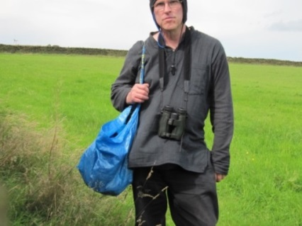
LETTER TO A TODMORDEN FARMER BASED ON TB NOT INFECTIOUS

From: John Wantling, Rochdale
Email: john.wantling@btinternet.com

To: Farmer Graham Hollows
Todmorden OL14 6JW

Monday 13th February 2017

Re: TB not infectious

Dear sir (Farmer Graham Hollows)
The main point I make in this (enclosed) Welsh letter is that the academics are focusing on the wrong (environmental) bacteria. As far as I can see, bovine or human TB isn’t related to environmental bacteria; it is related to the body which generates TB as a defensive response to a threat, such as a poison. When we understand that TB isn’t an infectious process, we can then begin to understand this issue better. If I am right, and I doubt that I am wrong, then the Badger Trust and the Welsh or English government are totally wrong about biosecurity and slaughtering healthy cattle and badgers etc. I have had a response from the Welsh government but it is unlikely that the Badger Trust will understand or accept my claims. In fact, the Badger Trust banned me a couple of years ago because I condemned them for following the politics for their own political ends. If I am right, then they have made a monumental blunder, and underneath, I believe that they know this, but they must stay with the politics as this is their bread and butter. When they do this, they are not siding with truth, but that is their own affair.

I cover this in my writings where I claim that the ‘science’ and the consequent knowledge that we have gained, meaning students, academia and farmers etc., have been led astray, meaning that the theory of infectious TB has been conditioned into us for the last 100 years or more, and so, being raised in this atmosphere, the tendency is to accept it without a thought, and then we repeat it, and then we defend it, which is tantamount to an infectious program that has been installed into our brains, in which we then place our faith. It is this conditioning factor that says that TB is infectious, but not one human on this planet earth can ever support that because the mode of transmission remains unknown. Academia must find it, but they can never find it, and so they must support it with another theory, for example, the ‘hidden pocket of disease’ theory, which is pure guesswork. This means that they support one theory with another theory, which is nothing more than self-deceit.

Environmental bacteria do not make humans sick. How many pet owners (cat, dog, rat, mouse, horse, rabbit, and bird) have ever ‘caught’ a disease off their animals? How many staff employed in zoos has ever ‘caught’ a disease off the zoo animals. Nobody has ever done this; it is not possible unless related to trauma or poison. I go to Chester Zoo mainly to the bat house. Bats fly around, urinating in a fine spray in which humans breathe in, we all get infected, but no one gets sick. The cow or sheep farmers are no different. There is no ‘infectious’ process, at least related to disease, but we all believe that there is, and this is how we see bovine TB through this infectious theory, which happens to be a myth. This is because TB the disease isn’t related to an outside-in process in the sense of being infectious. However, it is related to a poison causation, which is where the mode of transmission can be found, followed by a healthy immune response - the true cause of tuberculosis.

I realise that this is almost impossible to take in because by default, we automatically revert to our knowledge that tells us that bovine TB is infectious, and so we find it incomprehensible to ever believe that this infectious model is only a theory, not a fact. This is why academia is no longer scientific in the true sense of the word; they are now theoreticians, which is a tragedy. They no longer deal with facts, they deal with theories. This infectious theory has caught on, it is popular, it is fashionable, it is political, but it will always remain a theory - never a fact.

If the local baker offered you a theoretical loaf of bread, would you purchase ‘it’ from him knowing full well that you will go hungry. I doubt it very much, but regardless of that, you have bought a theory off a theoretician, and that is also a tragedy. DEFRA have a job to do, to focus on and to defend this infectious theory. They fund Professor Rosie Woodroffe to search for the mode of transmission, but they both know full well that this is pointless whilst she focuses on environmental bacteria. You can be sure that she will not be looking at the internal metamorphosis; because if she did that, DEFRA would no long fund her and her job and pension would be in ruins. This is an example of politics driving the science, the cart being placed before the horse, and it is this corruption in science that wittingly or unwittingly we all defend. This is nothing more than a conditioned response.
John Wantling

