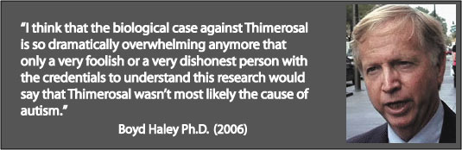

The Editor
The Spectator 23 July 2007
22 Old Queen Street
London SW1H 9HP
Telephone: 020 7961 0200
Dear Sir
Re: Ron Liddle’s article 'Wakefield is probably wrong about MMR, but I am glad he has taken his stand.'
I have to say it doesn't say much for his intelligence that he can't deduce the truth in the situation, although riding on the back of the medical profession is displaying a certain feral intelligence, and is what we have to put up with today, journalists displaying a remarkable level of ignorance on medical history and politics so they (surprise, surprise) end up believing what they can write, and not believing what they can’t, so they sing a song in tune with the hymn sheet of the Powers That Be that control their journalistic destiny, but this piece is very insulting on numerous levels, and unnecessarily so.
It is a great insult to my intelligence, and the intelligence of parents of autistic children whom he greatly insults with the phrase: 'cabal of autism groupies', many of whom have been looking into vaccination for years and have seen their children very obviously damaged by vaccines, and had to deal with the consequences without any help from the medical profession.
Regarding his comment: ‘The medical profession, almost as one, and the government insist that he is a charlatan, a quack.’
Let’s clarify one thing (“The beginning of wisdom is to call things by the right names”—Chinese Proverb) what he calls ‘the medical profession’ is in fact Allopathy, our covert medical monopoly, which also hides behind the names: Orthodox, Modern, Scientific, Contemporary, Traditional or Conventional Medicine. As distinct from Alternative (Non-Allopathic) medicine such as Naturopathy, Ozone therapy, Nutritional medicine, Homeopathy, Herbal medicine, Chinese medicine etc. And there isn’t any difference between the ‘government’ and ‘medical profession’, as Allopaths run the government health departments, have done for over 200 years.
Anyway, he should know that this argument is called 'The Fallacy of Authority, or Appeal to Authority or the Majority' (Argumentum ad populum), in other words logical fallacies. What would you expect them to do? Kick away one of the foundation stones of Allopathy, admit they had lied or been complete idiots, and open themselves up for billion pound litigation (there being 500,000 people in the UK with ASD)? Study medical history and you will know that isn’t going to happen.
Secondly, calling anyone a quack just means they practice non-Allopathic medicine or have been excommunicated from the Church of Allopathy, most probably because they became anti-vaccine, a vaccine or drug critic, or started to use non-Allopathic medicine. So calling him a quack is absolutely meaningless, in reality. More a mark of endorsement in my book.
As for the safety of MMR, MMR has been proven unsafe once before (Mr Liddle obviously doesn't know this) when, in 1992, MMR Pluserix was withdrawn in the UK after it was revealed that many children had developed meningitis. And this was 2 years after it was withdrawn in Canada, they then off-loaded their unsafe vaccine to Brazil where a hospital in Salvador was said to have been "saturated" with encephalitis cases. Such is the integrity of Dr Wakefield's accusers.
New information just obtained under FOIA shows in 1990 in the UK there were at least 7,480 adverse vaccine reactions and 1,990 serious ones with approximately 70 deaths associated with triple vaccines (DTP and MMR).
Secondly it is pretty obvious that MMR vaccine is killing children right now (more than measles would be doing incidentally without vaccination), as the government has paid out for such deaths. Hardly an indication it is safe, which is what they keep telling us all the time. So they are outright lying, another example of their lack of integrity. Also one of the GMC panel members (he may have removed himself now), Professor McDevitt, actually approved this vaccine!
Now, if they withdraw this one that would probably be the end of MMR, and if that goes then the vaccine programme would look decidedly shaky, and it is only vaccination that makes Allopathy look good. That is why Wakefield has to be burnt at the stake.
Here we have a man of great integrity who is putting the kids before anything else (unlike the Medical Profession/Government), and is one of the handful of doctors who is treating these very damaged children, and Mr Liddle sets out to pour more oil on his pyre.
How absurd to denigrate him using financial motives when his accusers make around a Billion dollars on each vaccine every year and it is a significant part of a medical doctor's income! As well as a huge source of hidden income in the way it causes diseases such as asthma, now affecting 1 in 5 children, eczema, ear problems etc.
"A young Australian lady, living in England, organized one of my many seminars there and told me that her father told her "go to Viera's seminars and do not vaccinate your children. All those ear infections, and problems like glue ear, are caused by vaccination". When I asked her who is her father, she said "he is an ENT specialist in Brisbane, Australia". --Viera Scheibner
You can work out how many doctor visits that is along with the ££millions in medication.
Liddle: He is this year's Sir Roy Meadow.
That is a great insult and betrays complete ignorance. Was he glad he has taken his stand just so he could throw rotten eggs at him? It appears so. Meadows sat on the Department of Health sub-committee on adverse reactions to vaccines as far back as 1987, yet told the Sally Cark jury that he could not think of any natural explanation for her children's deaths, even though they died shortly after vaccination, and the DPT vaccine has a long history of causing severe brain damage (the UK gov has also paid out for 900 brain damaged victims of DPT vaccine) (1) and death! He was quite happy to cover up his medicines cause of their death, blame the victims and help put them in jail, something that eventually killed one of them, Sally Clark. As well as ignore the 57 year old cure for cot-death and similar child deaths in the shape of Vitamin C, and ignore the main cause of child death—vaccination.
He then champions the victims for bringing Meadows to court, yet here he is rubbishing yet another group of vaccine and medical industry victims! What sort of logic is that?
He then admits to his limited medical understanding, and then goes on to prove it by championing the obvious medical snow job with the genetics and better diagnostic techniques bullshit, that has been taken apart by medical men such as Dr Peter Fletcher, former chief scientist at the Department of Health, but is pretty obvious for anyone to find out who is after the truth, rather than what Mr Liddle was after, a convenient piece of medical propaganda.

"At this point, it is believed that about 10% of cases of autism can be accounted for genetically."--B.J. Freeman, Ph.D. Professor of Medical Psychology, Dept. of Psychiatry and Biobehavioral Sciences' UCLA School of Medicine.

And that 10% could just be genetic susceptibility to mercury.

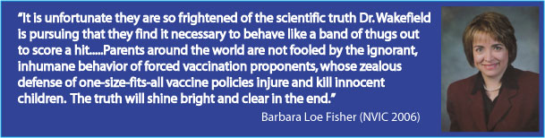
“If the medical profession honestly thinks that the "increase" in autism is an artifact produced by historical diagnostic ignorance, they should think again.
Because in the minds of people who DO remember a time when Autism was something you checked in the dictionary as to how to spell the word, such a statement isn't just ludicrous; it also raises questions, and these questions are:
What have doctors got to hide, that they want to try to persuade people that a "real" increase (that we as long term teachers see as a "real" increase,) was actually a result of their own stupidity? Are doctors trying to tell us, that we, as teachers, were also so stupid that we didn't see "autism" then, but do now?
What does such an "explanation" show about their new-found intelligence today? ----Hilary Butler. Letter BMJ 2005

Again, on the subject of integrity, he should know (they certainly do, at the top) that there isn't the slightest shred of evidence measles vaccine eliminated measles deaths (morbidity would be tied to deaths) as deaths had declined by 99.4% before vaccination! (1).
Secondly, they have had the knowledge since 1949 to make measles completely safe with vitamin C injections. So measles/mumps/polio/meningitis etc vaccination are completely unnecessary (2) (as well as being completely ineffective).
"Many viral infectious diseases have been cured and can continue to be cured by the proper administration of Vitamin C. Yes, the vaccinations for these treatable infectious diseases are completely unnecessary when one has the access to proper treatment with vitamin C. And, yes, all the side effects of vaccinations...are also completely unnecessary since the vaccinations do not have to be given in the first place with the availability of properly dosed vitamin C."---Dr Thomas Levy M.D., J.D. (2)
What does that tell you about their concern about the truth and children?
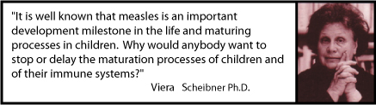
There is also a large body of evidence to show that measles is a necessary elimination process of the immune system (they certainly haven’t proven otherwise), the suppressing of which leaves you open to more serious diseases later in life, which indicates vaccination is still an experiment, also shown by the fact only 20% of the immune system is understood at this point in time, so all vaccination is still an experiment.
As to his belief vaccines don't cause autism, perhaps he could spend some months talking to the thousands of parents around the world who know otherwise, as well as the numerous medical professionals who also know otherwise like Dr. Boyd Haley, Professor and Chair, Dept. of Chemistry, University of Kentucky (see above quote), to help remove those blinkers he can’t even see. Now he can, I have told him.
Or read Dan Olmsted who found no autism among the unvaccinated Amish, or Dr. Mayer Eisenstein, who said "We have a fairly large practice...We have about 30,000 or 35,000 children that we've taken care of over the years, and I don't think we have a single case of autism in children delivered by us who never received vaccines." http://www.theageofautism.com
Or David Ayoub, MD: "I am no longer "trying to dig up evidence to prove" vaccines cause autism. There is already abundant evidence,...... This debate is not scientific but is political."
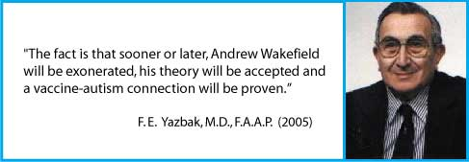
Or Bernard Rimland, PhD ( http://en.wikipedia.org/wiki/Bernard_Rimland): "The evidence is now overwhelming, despite the misinformation from the Centers for Disease Control and Prevention, the American Academy of Pediatrics and the Institute of Medicine." (4)
Maybe the truth is too much for Ron Liddle, but he should bear in mind every day this vaccine is on the market hundreds more children are given devastating conditions such as autism. The last one was withdrawn so they have circled the wagons on this one.
As for the many epidemiology ‘studies’, they have all been shredded by the likes of Dr Yazbak. http://www.vaccination.org.uk/vaccines/yazbak.html More lies and deception.
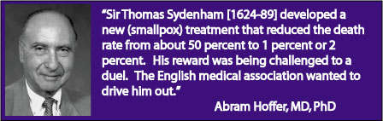
So we have a modern day Semmelweis or Sydneham being crucified for helping vaccine damaged children; damaged by a vaccine that is easily proven to be completely ineffective just from government statistics, but very effective in killing (as demonstrated by the government paying out) and maiming children. For diseases such as mumps and measles that are completely safe under nutritional medicine (Vitamin C), or other proper medical care.
"Under normal conditions, healthy children do not die from or become disabled from the complications of measles and if they do, questions should be asked about their management." ---Letter BMJ Feb 2005. Donegan MB.
While the Vaccinators (Allopaths/medical profession) make out he isn’t fit to practice using some spurious excuses. Isn’t it all a bit obvious? I think Liddle needs to take off his blinkers, and not support their dirty work, with such relish.
Yours etc

PS. Yes, I know mercury isn’t in the MMR vaccine. His comment something dark, mysterious and catastrophic lurking within the MMR vaccine suggests he hasn’t the faintest idea what actually is in a vaccine. But then, ignorance is a useful ally when writing such pieces, where you don’t want to rock the boat, and it is more convenient to throw more mud at medical industry victims.
"If you have an autistic child you might consider that one of the components of the MMR is Neomycin. This is an antibacterial drug that is used to suppress gastrointestinal bacteria before surgery to avoid infection. It is also used in a variety of preparations, too numerous to mention here. This antibiotic interferes with the absorption of Vitamin B6. An error in the uptake of Vitamin B6 can cause a rare form of epilepsy and children become mentally retarded. Vitamin B6 is the major vitamin for processing amino acids, which are the building blocks of all proteins and a few hormones. There are studies around which support the theory of treating autistic children with Vitamin B6."---Carol A Teasdale
"As a clinician, my current belief which guides my practice with these children is that any child given the HepB vaccination at birth and subsequent boosters along with DPT has received unacceptable levels of neurotoxin in the form of the ethyl mercury in the thimerosal preservative used in the vaccine. In any child with a genetic immune susceptibility (probably about one in six) this sets off a series of events that injure the brain-gut-immune system. By the time they are ready to receive the MMR vaccination, their immune system is so impaired in a great number of these children that the triple vaccine cannot be handled by the now dysfunctional immune system and they begin their obvious descent into the autistic spectrum disorder."---Jaquelyn McCandless, M.D
References:
1. Making the case for Government Compensation for those damaged by Vaccines by
Wm. H Wain BEM http://www.vaccination.org.uk/vaccines/wain.html
2. Twentieth Century Mortality CD, Office of National Statistics http://www.vaccination.org.uk/m/measlesdeaths1.html

3. Vitamin C, Infectious Diseases, and Toxins: Curing the Incurable by Thomas E. Levy, M.D., J.D. (Has 2,000 peer reviewed citations).

4. Dr Rimland http://www.vaccination.org.uk/v/rimland2.html
