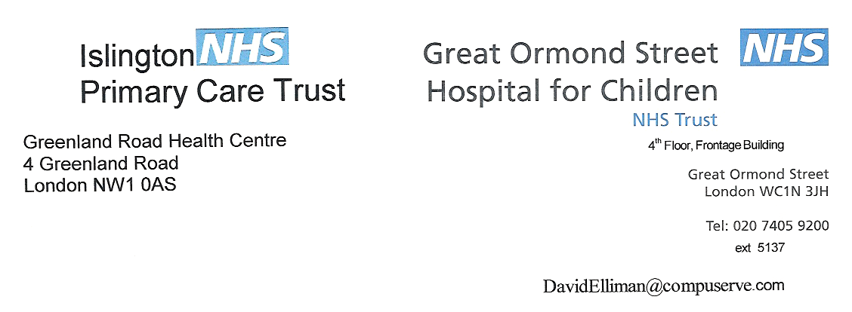
7th Floor, Old Building

7th Floor, Old Building
Great Ormond Street Hospital for Children
Great Ormond Street
London, WC1 3JH
020 7405 9200 ext. 5137
Ellimd@gosh.nhs.uk

June 2006
Dear Sir / Madam,

The time has come to draw a line under the question of any association between MMR vaccine and autism. The UK’s children are in danger of serious illness or death if they are left unimmunised. The number of confirmed cases of measles has increased dramatically this year and, only a few months ago, we had the first death from measles since 1992.

A large body of scientific evidence shows no link between the vaccine and autism or bowel disease. Confidence in the safety of MMR had been returning and its uptake slowly increasing, so it would be tragic if it is once again shaken by ill-informed reporting of inadequate, preliminary research and supposition.

An example of this is recent media reporting of research from America. The principal researcher made it clear that their findings of measles virus in the gut of the children with autism did not prove a link with the MMR vaccine. However, little media coverage was given to this statement and none to another piece of research showing how difficult it is to accurately test for the measles virus.

We are now faced with a potentially serious situation. Years of low uptake mean large numbers of unprotected children are now entering school. Unless this is rectified urgently, and children are immunised, there will be further outbreaks and more unnecessary deaths. It has been suggested that allowing parents to choose single vaccines would have averted this situation. The reasons why this would not be an effective solution have been well rehearsed. In spite of having carefully considered this option, no country offers them as an alternative to the MMR vaccine.

It is not too late to avert this predictable tragedy. It is time that due weight is given to the overwhelming body of scientific evidence in favour of the vaccine. Misguided concepts of ‘balance’ have confused and dangerously misled parents. We all, media, politicians and health professionals, have a responsibility to protect the health of our children.

Yours faithfully

Dr David Elliman
Consultant in Community Child Health, Great Ormond Street Hospital, London

Dr Helen Bedford
Senior Lecturer in Children’s Health, Institute of Child Health, London

Dr Patricia Hamilton
President of the Royal College of Paediatrics and Child Health, London

Dr Mario Abinun
Consultant Paediatric Immunologist, Newcastle upon Tyne

Professor Andrew J Cant
Consultant in Paediatric Immunology & Infectious Diseases, Newcastle upon Tyne

Dr Julia Chisholm
Consultant Paediatric Oncologist, Great Ormond Street Hospital, London

Dr Natasha Crowcroft
Health Protection Agency, London

Dr E Graham Davies
Consultant Paediatric Immunologist, Great Ormond Street Hospital, London

Professor Carol Dezateux
Professor of Paediatric Epidemiology, MRC Centre of Epidemiology for Child Health, Institute of Child Health

Professor Adam Finn
Professor of Paediatrics, University of Bristol

Dr Annabel Foot
Consultant Paediatric Oncologist, Bristol Children's Hospital

Professor David Goldblatt
Professor of Vaccinology and Immunology, Great Ormond Street Hospital, London

Professor Sir David Hall
Emeritus Professor of Community Paediatrics, University of Sheffield

Dr Anthony Harnden
University Lecturer and Principal in General Practice, University of Oxford

Dr Paul Heath
Senior Lecturer and Honorary Consultant, Paediatric Infectious Diseases, St Georges Hospital, University of London.

Dr Nik Johnson
Consultant Paediatrician, Hinchingbrooke Hospital

Dr Sally E Kinsey, Consultant Paediatric Haematologist, St James's University Hospital
Leeds

Professor Simon Kroll
Professor of Paediatrics, Imperial College, London

Professor Stuart Logan
Professor of Paediatric Epidemiology, Peninsula Medical School, Exeter

Professor Neil McIntosh
Professor of Child Life and Health, Edinburgh

Professor Richard Moxon
Action Research Professor, University of Oxford

Professor Angus Nicoll CBE
Health Protection Agency, London

Dr Vas Novelli
Consultant and Lead Clinician in Paediatric Infectious Diseases,
Great Ormond Street Hospital for Children

Dr Andrew Pollard
University Lecturer and Honorary Consultant Paediatrician, Oxford Vaccine Group, University of Oxford

Dr Mary Ramsay
Health Protection Agency, London

Dr Martin Richardson
Consultant Paediatrician, Peterborough District Hospital

Dr Roderick Skinner
Consultant in Paediatric Oncology and BMT, Newcastle upon Tyne

Professor Brent Taylor
Professor of Community Child Health, University College London

